

CANDIDATE MANUAL

Revised July 2024



©New-2-ICU (AP Georgiou, ME Garcia Rodriguez) 2009



Contents
Foreword | 3
Course Programme | 4

Supporting Materials for pre-course reading and post-course information:
1. Airway | 5
2. Breathing | 15
3. Circulation | 20
4. Sedation | 27
5. Drugs on the ICU | 31
6. Fluids, Feeding, Infection and Bundles, VTE | 36
7. Renal Replacement Therapy | 39

Foreword

Hello to you all

Thank you for your commitment to the New2ICU course.

The New2ICU course was established in 2009 and has been running twice a year since then in the Severn Deanery (Bristol), with excellent feedback and positive staff and patient experiences as a direct result of the learning which people have acquired form the course. The original aim was to improve the safety of patients on the Intensive Care Unit (ICU) by upskilling junior doctors before or immediately after rotation to ICU. Junior doctors rotate through different specialties where much of the skills and knowledge is transferrable form one specialty to another. The same is not necessarily true of intensive care, where a unique set of knowledge and skills in combination with a collaborative approach to patient care is required, in addition to much of the knowledge acquired from elsewhere in medicine. The unique set of knowledge and skills required on ICU may be completely new to junior doctors rotating through ICU for the first time, as they may not have learnt these elsewhere in their undergraduate or postgraduate training. Junior doctors are placed on the ICU on-call rota as soon as their rotation begins, often without direct supervision and so they have little or no time to be taught or to witness these skills which will enable them to work proficiently on the ICU or to manage dangerous or life-threatening situations competently until senior help arrives. This course aims to bridge that gap in knowledge and skills and increase the proficiency of junior doctors as soon as their ICU rotation begins.

There have been some changes to the course to allow it to continue during the COVID-19 pandemic. Some of these changes were positive and have been retained, such as smaller groups for teaching. We hope that in participating in this course, you gain the knowledge and skills which will allow you to manage serious or life-threatening situations on ICU prior to the arrival of senior help, and to equip you to contribute positively to patient care early on in your ICU rotation.
Welcome to the Intensive Care team. We hope you enjoy your time.

Andy Georgiou & Miguel Garcia Rodruiguez
Course Creators

Lizzie Williams, Sara Bonfield & Aravind Ramesh

Course Directors

Course Programme

Please meet in the Learning and Research (L&R) Building on Southmead Hospital campus, BS10 5NB.
https://www.bristol.ac.uk/media-library/sites/clinical-sciences/documents/southmead-hospital-map.pdf

It is in the ‘Science Quarter’ on the map and is best reached on foot after parking in the Brunel Car Park.

Lunch is provided in the L&R, as are morning and afternoon refreshments.

This manual is not essential pre-course reading, but you will find it helpful reference material to get you ready for the course, or to use afterwards as needed.

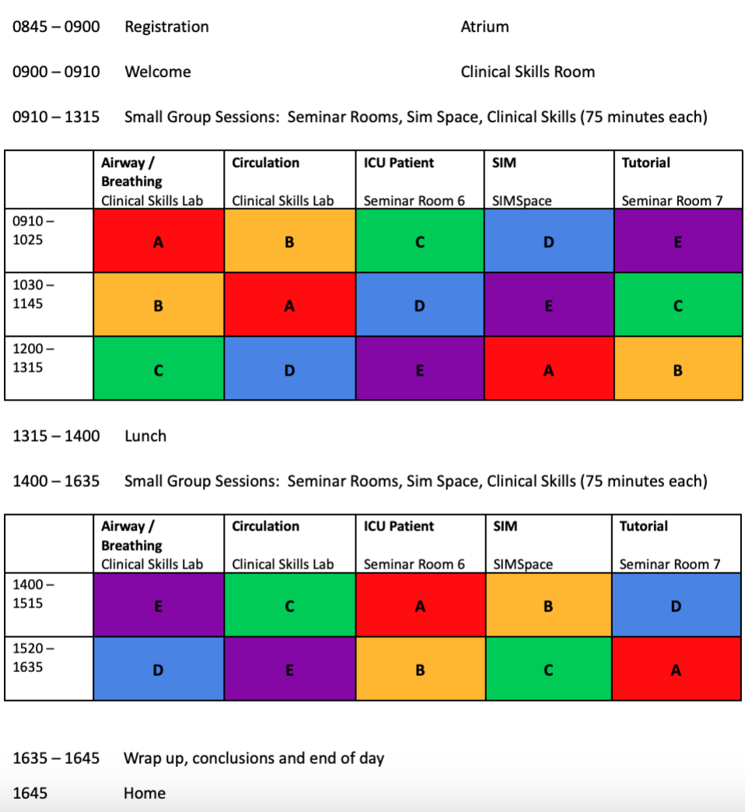
Timetable for the day:

1. Airway

  - Airway Equipment

You should become familiar with the following airway equipment
- Ambu/self-inflating bag and mask
- Water’s Circuit
- Nasopharyngeal airway
- Oropharyngeal airway (Guedel)
- Supraglottic airway (SGAs): laryngeal mask airway (LMA), iGel
- Endotracheal tubes
- Capnography
- Yankauer sucker
- Laryngoscopes

Facemask
- Chose the correct size mask which should cover the nose and mouth
- Use two-person technique to optimise effective ventilation

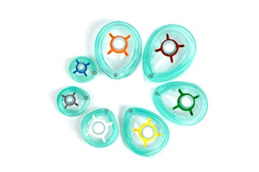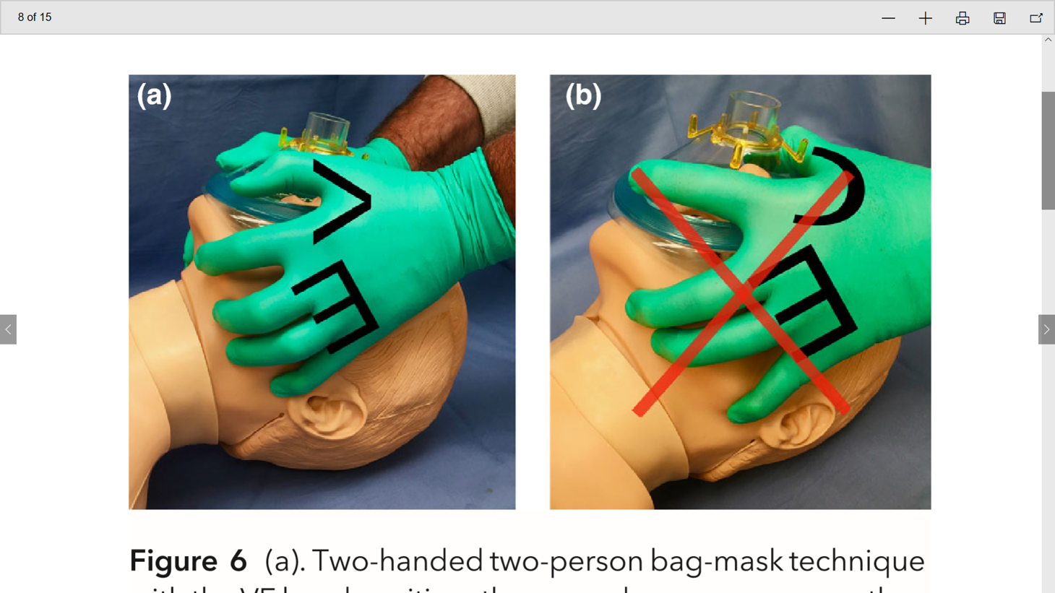

(a). Two‐handed two‐person bag‐mask technique with the VE hand position; the second person squeezes the bag.
(b). The CE hand position, is a one person technique and should be avoided if possible

From: Consensus guidelines for managing the airway in patients with COVID‐19
Guidelines from the Difficult Airway Society, the Association of Anaesthetists the Intensive Care Society, the Faculty of Intensive Care Medicine and the Royal College of Anaesthetists. TM Cook et al. March 2020.
https://doi.org/10.1111/anae.15054

Ambu or self-inflating bag
- Should be at every patient’s bedside, or the resus trolley and in the ICU grab bag
- Do not need fresh gas flow to ventilate patient (can use in power or oxygen delivery failure scenarios)

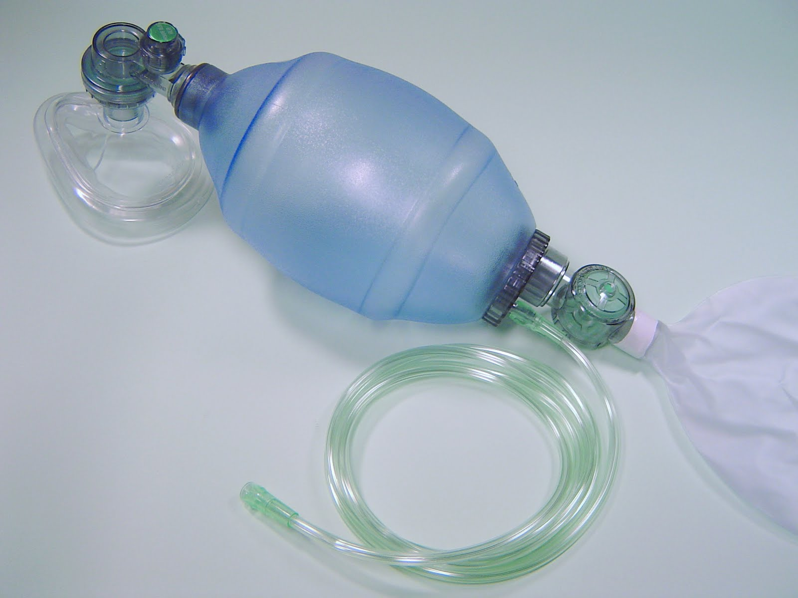

Water’s Circuit
- Needs fresh gas flow
- Can adjust PEEP using APL valve
- Do not throw away the connectors!

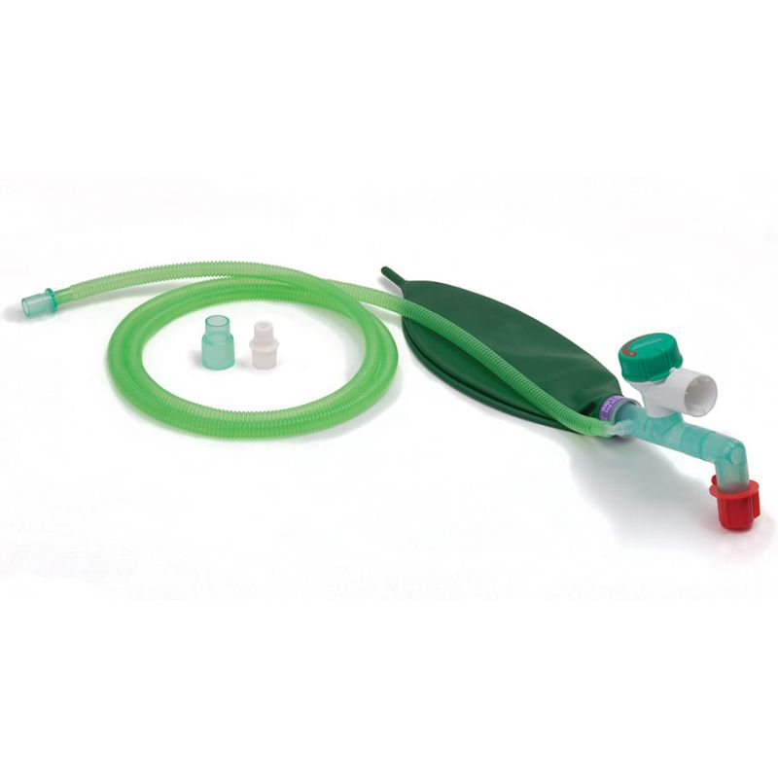

Nasopharyngeal and oropharyngeal airways
- Use correct size
- Take care to avoid airway trauma (particularly with NP airway)
- OP airway should be used to improve bag-mask ventilation and reduce gastric dilatation

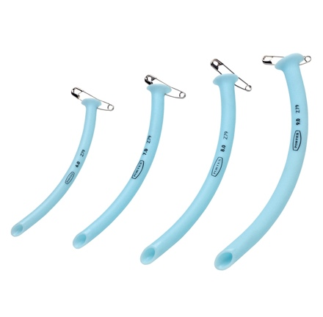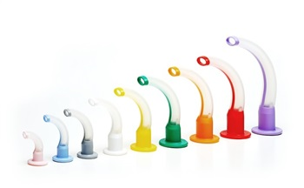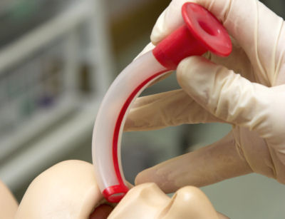

Supraglottic airway
- Can be used to aid oxygenation/ventilation during CPR, or as a rescue airway during failed intubation
- Usually size 3-4 in adult females, and 4-5 in adult males

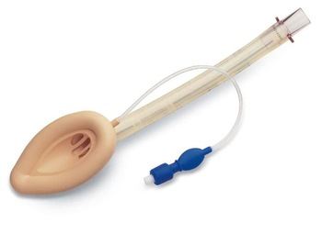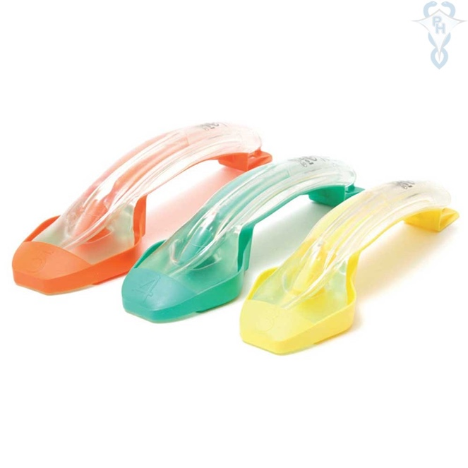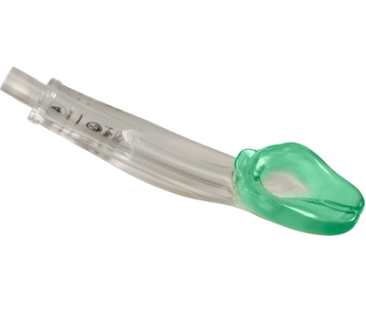

Endotracheal tubes (ETT)
- Usually size 7.0 – 7.5 in adult females, and 8.0-8.5 in adult males
- Should only be inserted by people trained to do so
- Have a cuff to inflate to enable airway protection and to generate ventilation pressures
- Often have a subglottic suction port on ICU (yellow port)

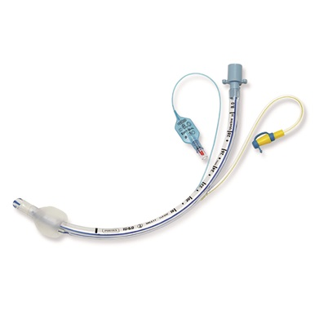

Laryngoscopes
- Used to aid endotracheal intubation
- Default on ICU is usually videolaryngoscopy, but should have two blades available with working light sources
- Videolaryngoscope blades: size 3, size 4, hyperangulated
- MAC blades: size 3 (adult females), size 4 (adult females and males)

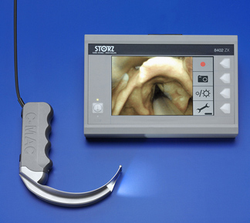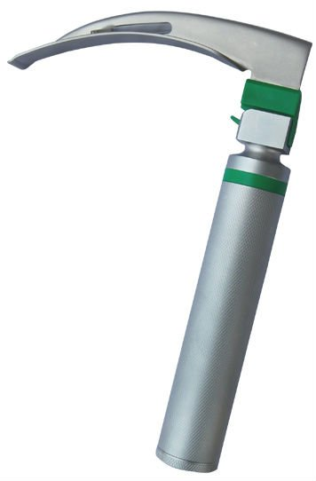

Bougie
- Used to aid endotracheal intubation
- Are found on in the packet on the side of the airway trolley

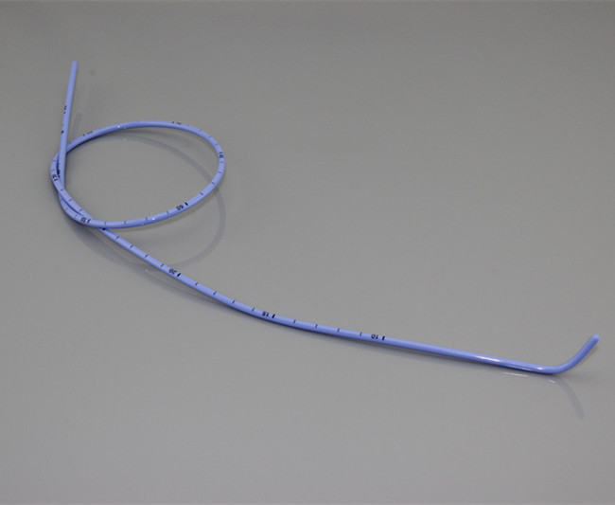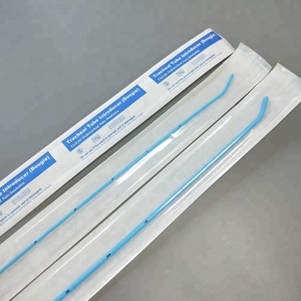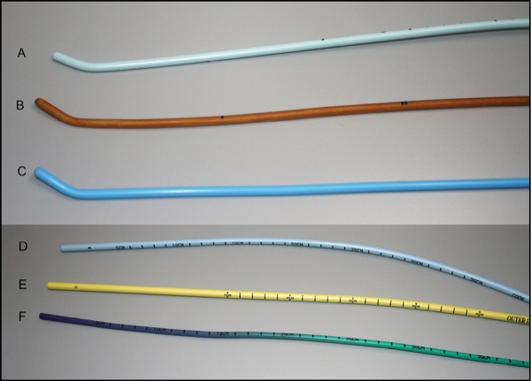

Capnography
- Essential equipment to confirm presence of patent airway and correct placement of airway device
- Demonstrates presence of carbon dioxide in expired gases (end-tidal CO2, ETCO2) and give quantitative value
- Can be used to assist with identification of presence of cardiac output or good-quality CPR during resuscitation

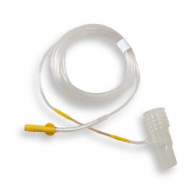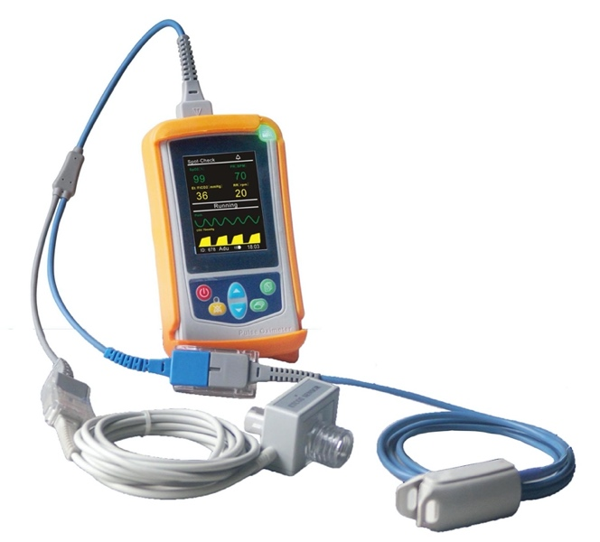

Yankauer Suction
- Suction catheter should be attached via tubing to wall or portable suction units

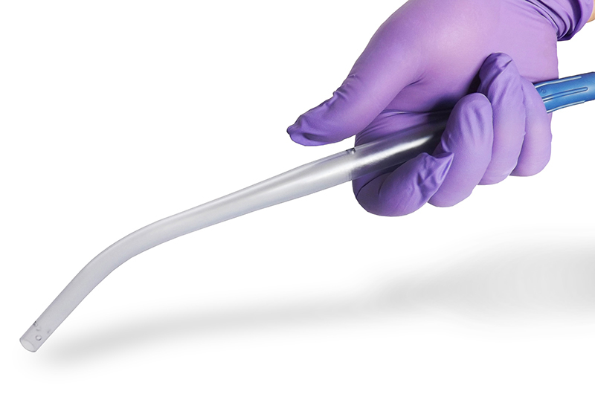

1.2 ETCO2 trace

- It is essential to confirm the correct placement of an endotracheal tube
- It should be used during any airway management event including bag-mask ventilation, and cardiac arrest
- All ICU patients should have capnography attached and displayed
- A lot of information can be obtained from the ETCO2 trace, including efficacy of ventilation, lung pathology, presence of cardiac output and effectiveness of CPR.

Please watch the following video about the use of ETC02 monitoring in cardiac arrest:

https://www.rcoa.ac.uk/safety-standards-quality/guidance-resources/capnography-no-trace-wrong-place

Examples of capnography traces

Normal ETCO2 trace
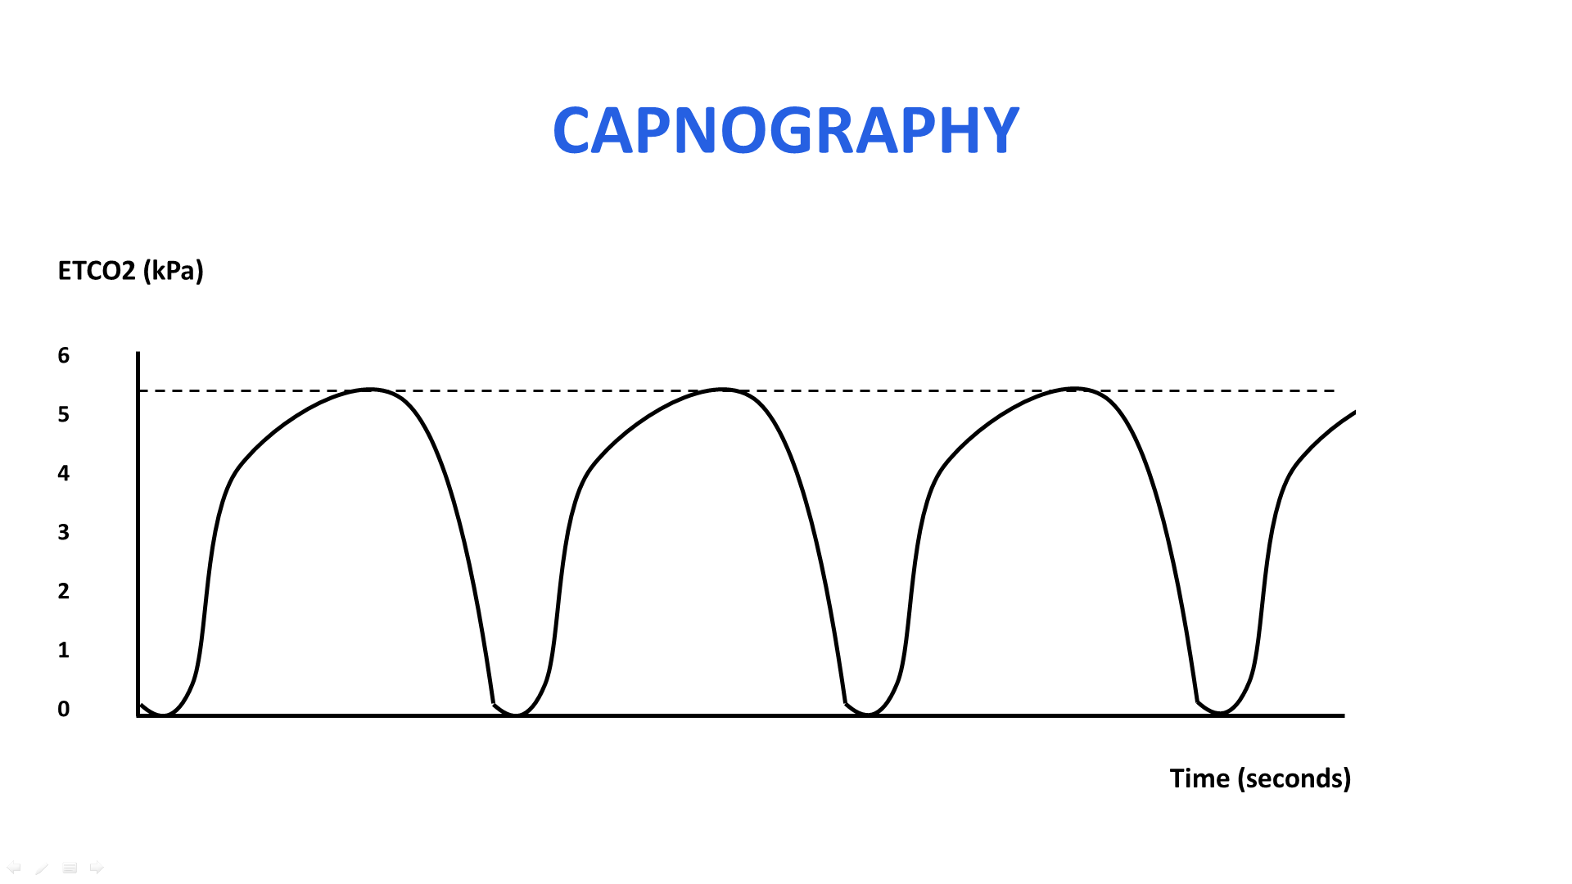

Increasing ETCO2 trace: hypoventilation, hypermetabolic

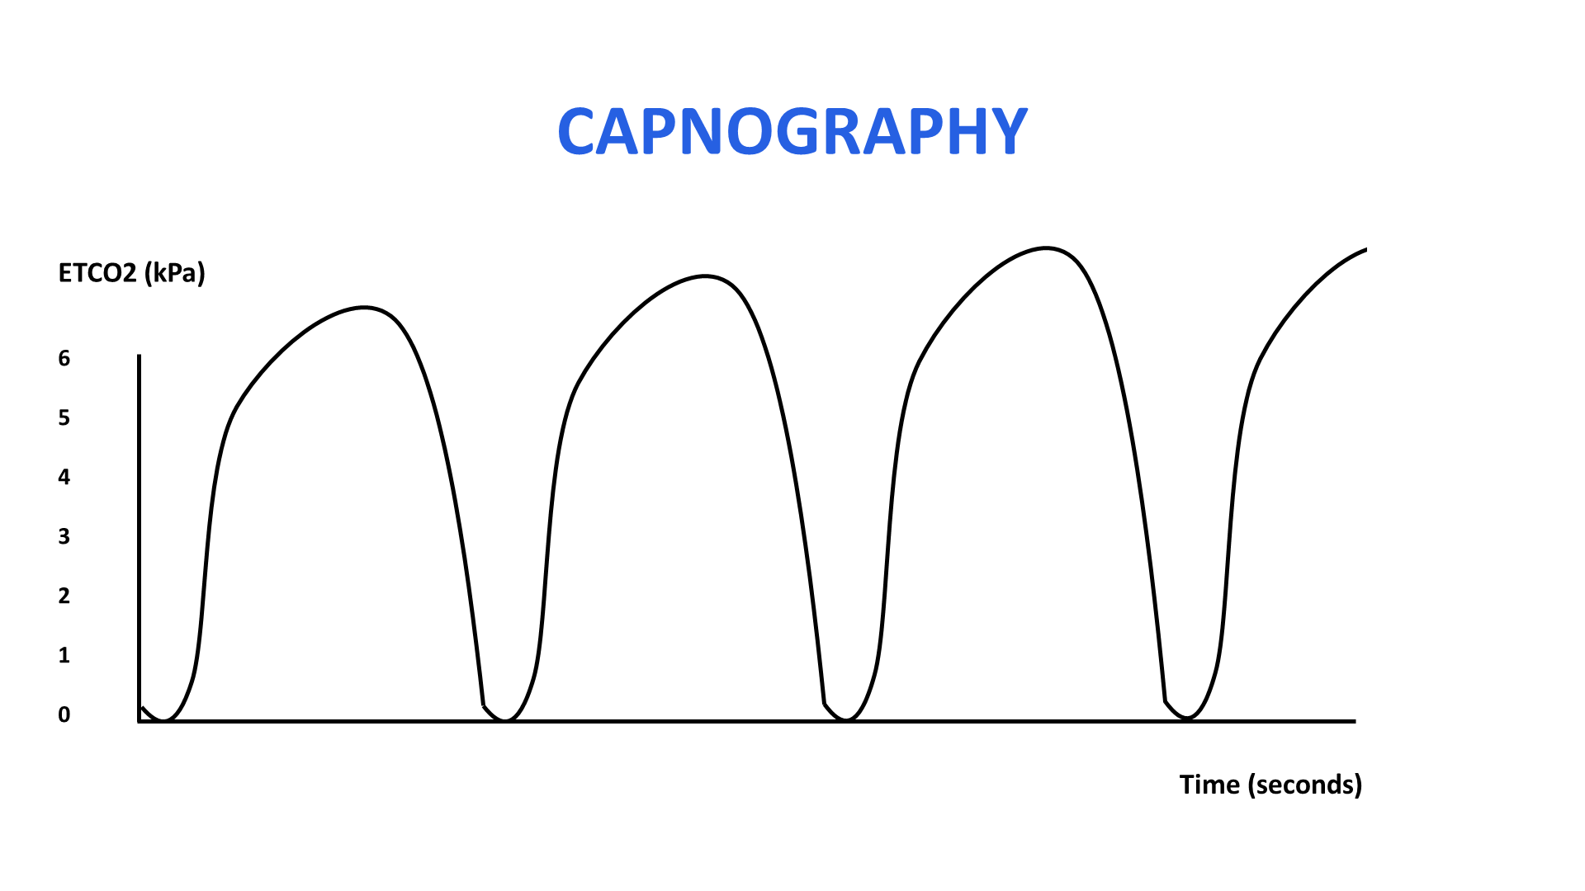

Upsloping plateau: obstructive picture eg bronchospasm
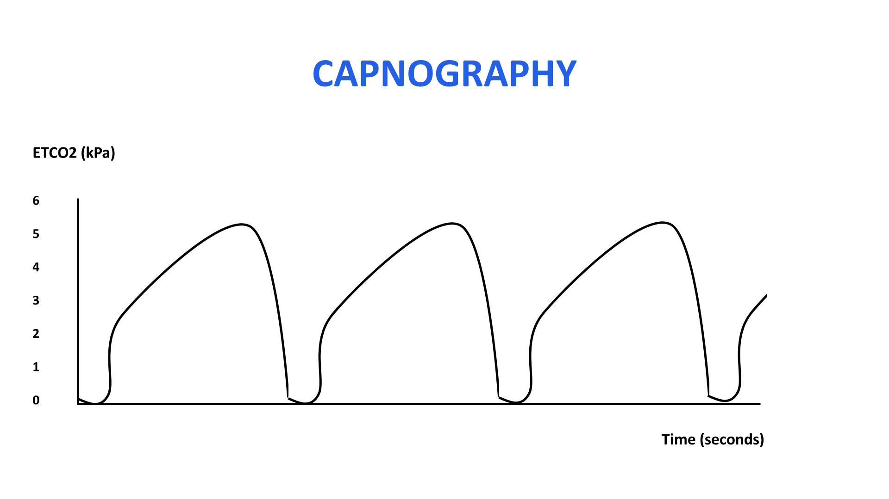

Variable trace: dyssynchrony with ventilator, coughing, etc
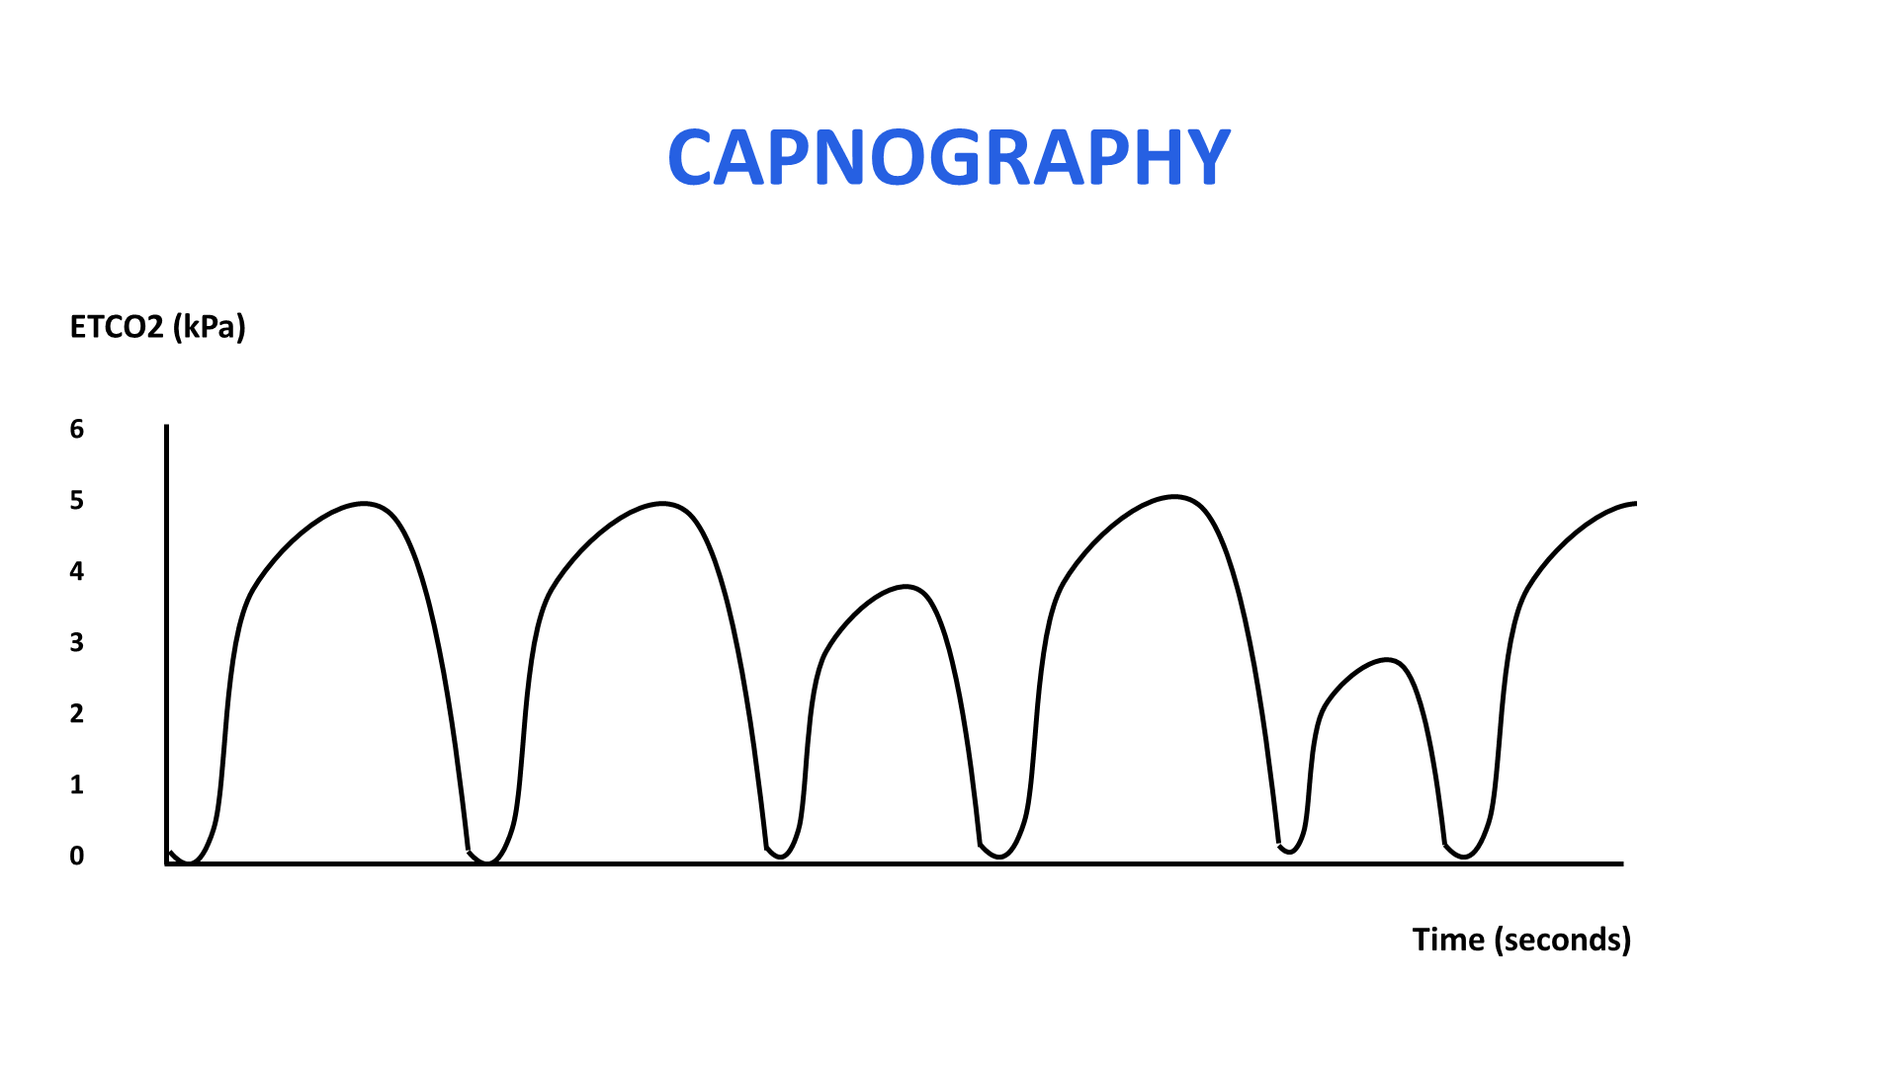

Attenuated trace: profound hypotension leading to cardiac arrest, possibly oesophageal intubation
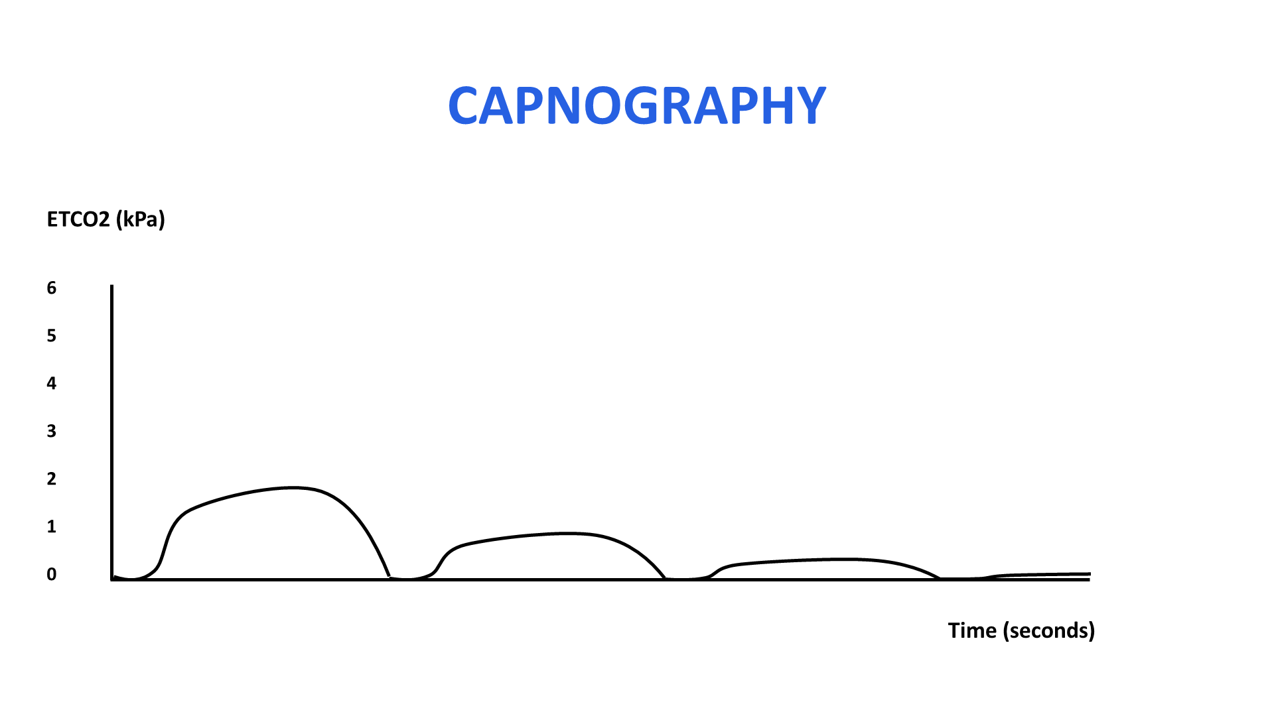

Cardiac Arrest: during cardiac arrest with CPR.
Cardiac arrest does not have a flat trace - approximate ETCO2 1.5 – 2kPa)
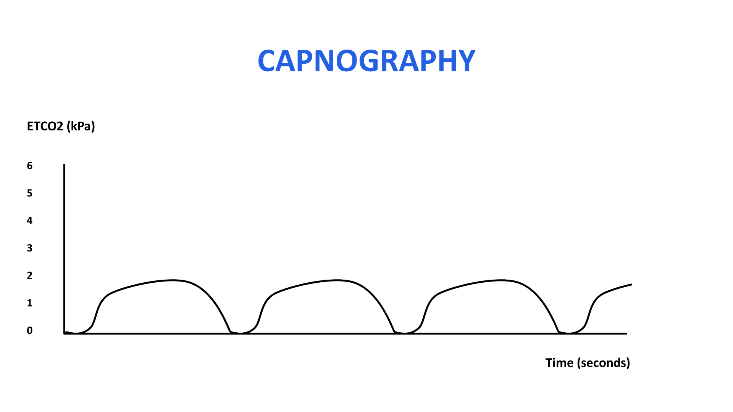

Return of spontaneous circulation following CPR
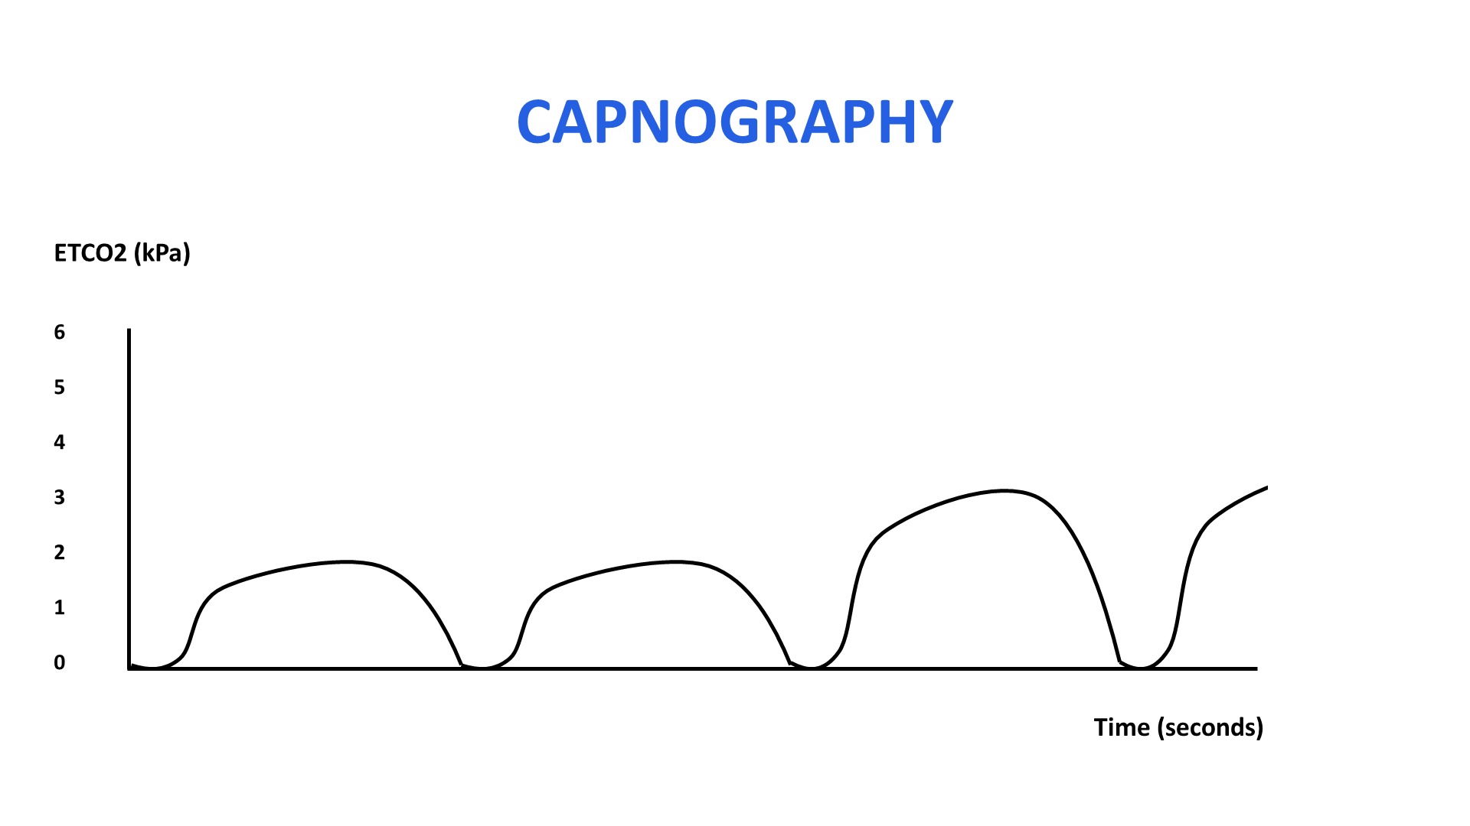

No trace: Flat line
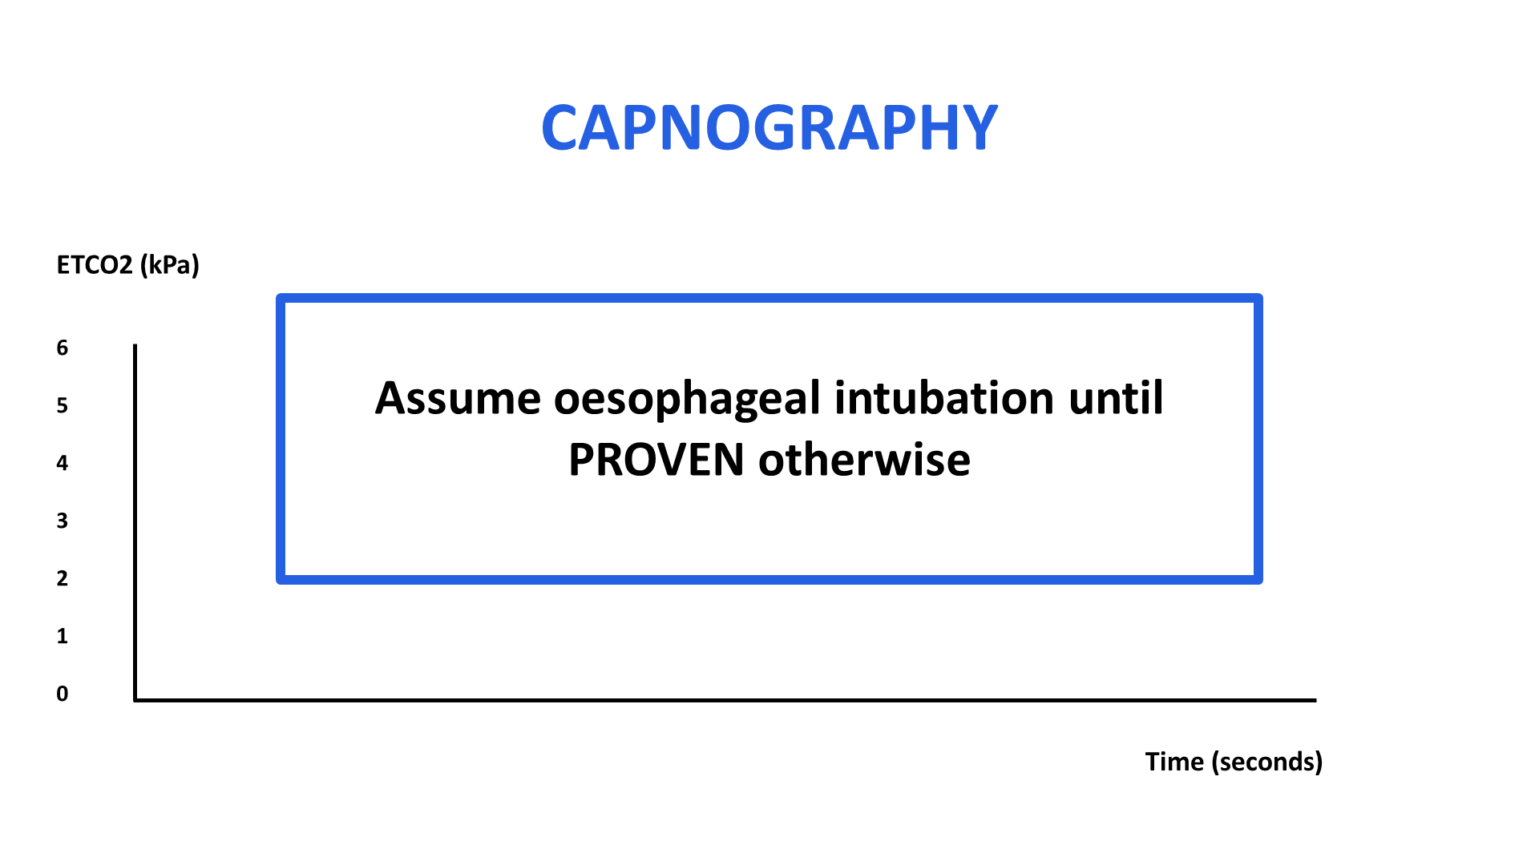

No Trace = Wrong Place – assume oesophageal intubation and remove ETT
Other less common possibilities: completely blocked ETT, circuit or capnogram
- If flat trace immediately after intubation, assume oesophageal intubation and remove ETT
- If flat trace showing on ICU patient monitor who has been intubated for a while, check for accidental extubation in the first instance, then check equipment.

1.3 Checklist for Tracheal Intubation

Checklists for tracheal intubation have become standard of care for intubations occurring outside the theatre environment. This includes ICU, obstetrics and the Emergency Department. The intubation checklist is on the New2ICU website.

They are designed to aid preparedness, and to ensure all members of the team are aware of what is about to happen.

They can be performed quickly and efficiently, and do not delay safe intubation.

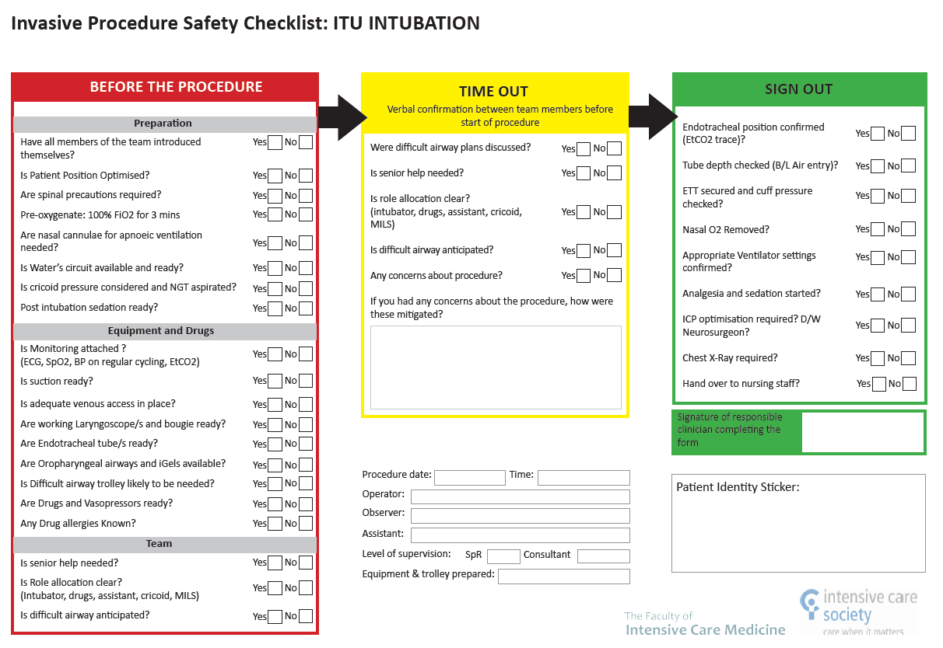

1.4 Drugs used for intubation

For more details, see Section 5 Drugs on the ICU

Sedation: Propofol, Ketamine, Midazolam
Opioids: Fentanyl, Alfentanil
Muscle relaxation: Rocuronium, Suxamethonium
Vasopressors: Metaraminol, Adrenaline

1.5 Tracheostomies

Understanding of tracheostomies is a vital part of ICU care. They may be permanent or temporary, newly placed or well-established. Regardless of the reason or length of time they have been in place, all doctors working on intensive care units should be able to troubleshoot and deliver immediate emergency care for these patients.

Tracheostomies on ICU are usually placed to facilitate ongoing ventilatory care. The benefits include:
- facilitating weaning of sedation and ventilation
- pulmonary toilet and improved oral care
- improved patient comfort, communication and daily living activity
- protection of the airway (e.g to avoid chronic aspiration)

These tracheostomies are often performed percutaneously by Intensivists on the ICU, but some are inserted surgically (patients with presumed difficulty eg obesity). They are inserted with temporary intent but may stay in for several months, depending on a patient’s recovery and progress. Other tracheostomies seen on ICU and around the hospital have been placed for airway or long-term ventilation concerns, for example post airway surgery.

In any patient with a tracheostomy, it is vital to distinguish patients who have normal upper airway anatomy from patients who do not. Patients who have normal upper airway anatomy can ultimately have their airway managed from the nose/mouth in the normal way in the event a tracheostomy is displaced or removed. The same is not true for patients who do not have normal upper airway anatomy (e.g. patients who have had a laryngectomy). unlike patients without a normal ) (and cannot have their airway managed in the normal way). This vital distinction should be clear at each patient’s bedspace so people attending in emergencies know how to manage an airway emergency and what is needed. It is also highly advisable to have the appropriate displaced tracheostomy algorithm at the bedspace of any patient with a tracheostomy (see below). These are available on the New2ICU website.

Displaced tracheostomy algorithms
A displaced tracheostomy algorithm was first devised by the New2ICU faculty in February 2009. Since then, there has been widespread recognition that an algorithm such as this can improve decision making and reduce cognitive burden on staff when faced with a tracheostomy emergency. The National Tracheostomy Safety Project (NTSP) has since published displaced tracheostomy algorithms which are available on their website here. We recognise that the NTSP algorithms are incredibly useful for staff from a wide variety of backgrounds, but in order to simplify the algorithms further and make them highly relevant only for staff who work on ICU (particularly junior staff), we have updated our algorithms, and these are illustrated below. Staff who work on ICUs should understand which algorithms their unit uses and refer to that in the interests of consistency. We have been teaching the algorithms below for over 15 years and have found that staff who are new to the ICU can learn, adopt and apply them quicky, so they are placed here for reference and adoption where appropriate.

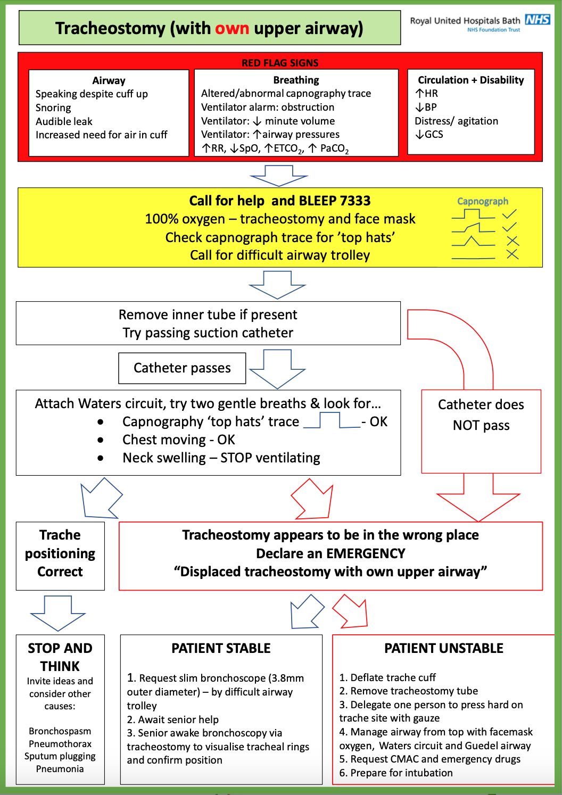

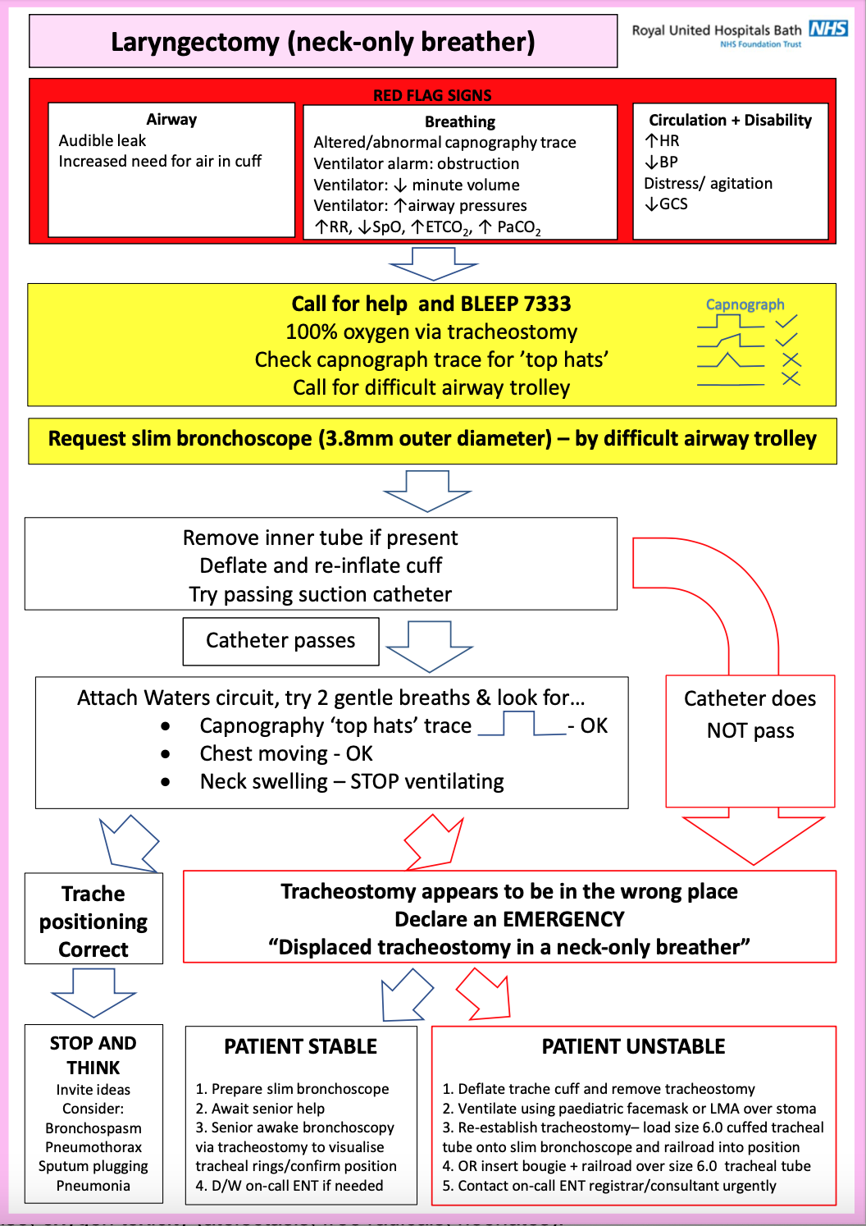

Tracheostomy tubes
There are many different kinds of tracheostomy tubes. Each patient should have spare tracheostomy tubes (and inner tubes) at their bedside, including one a size smaller than their current one. You should familiarise yourselves with what is in a tracheostomy bag which will be with the patient at all times.

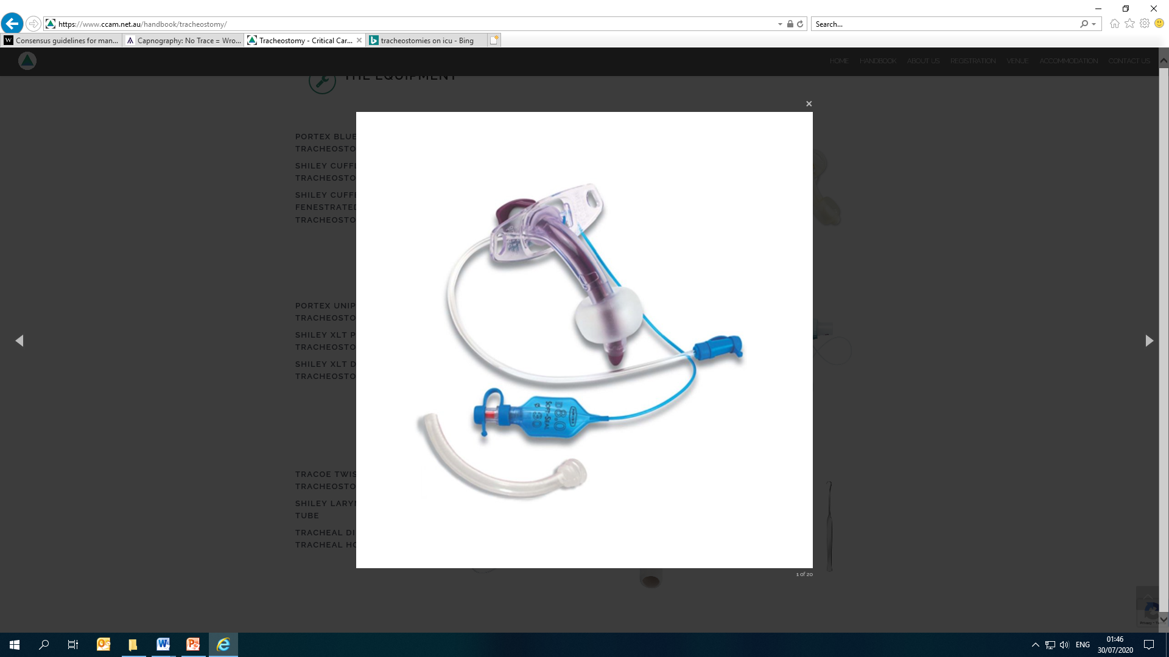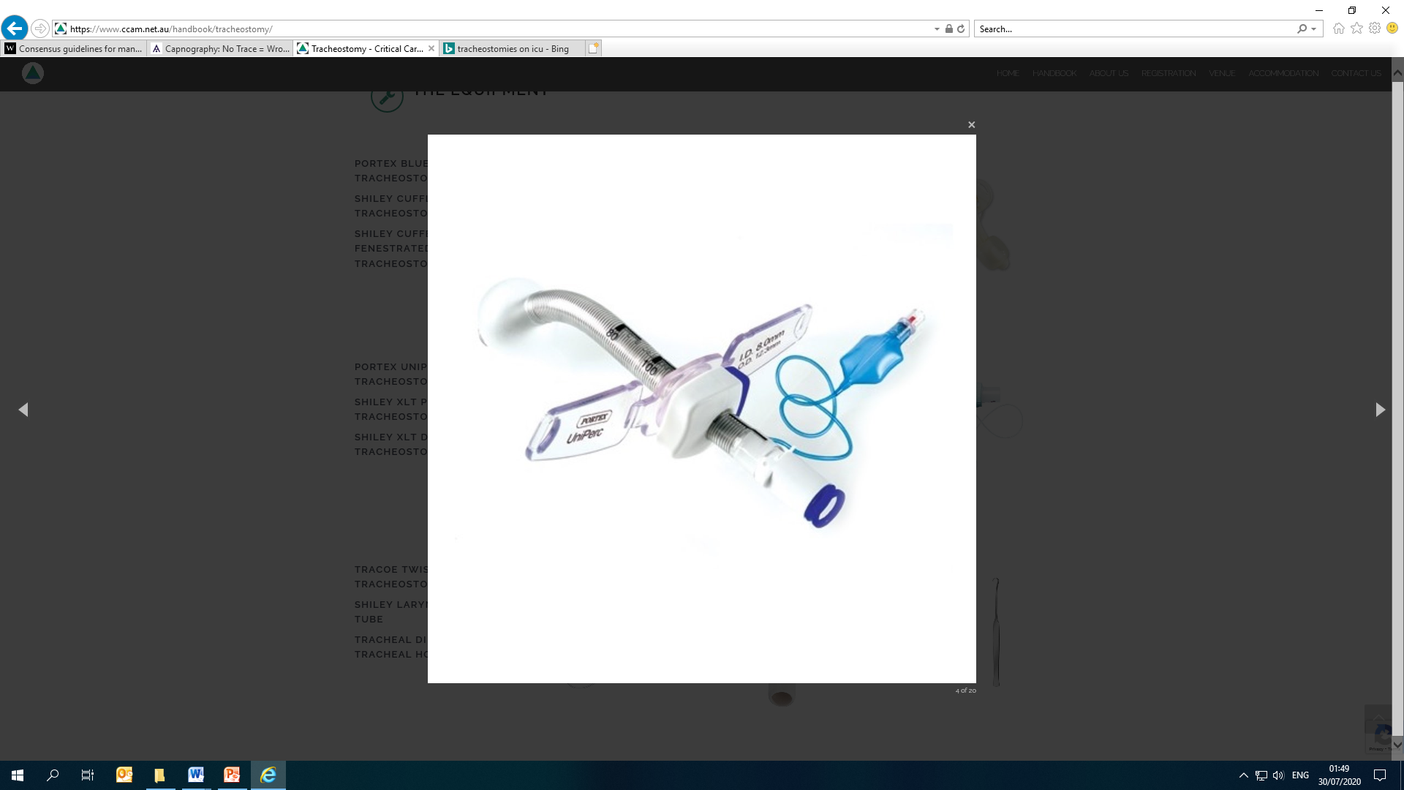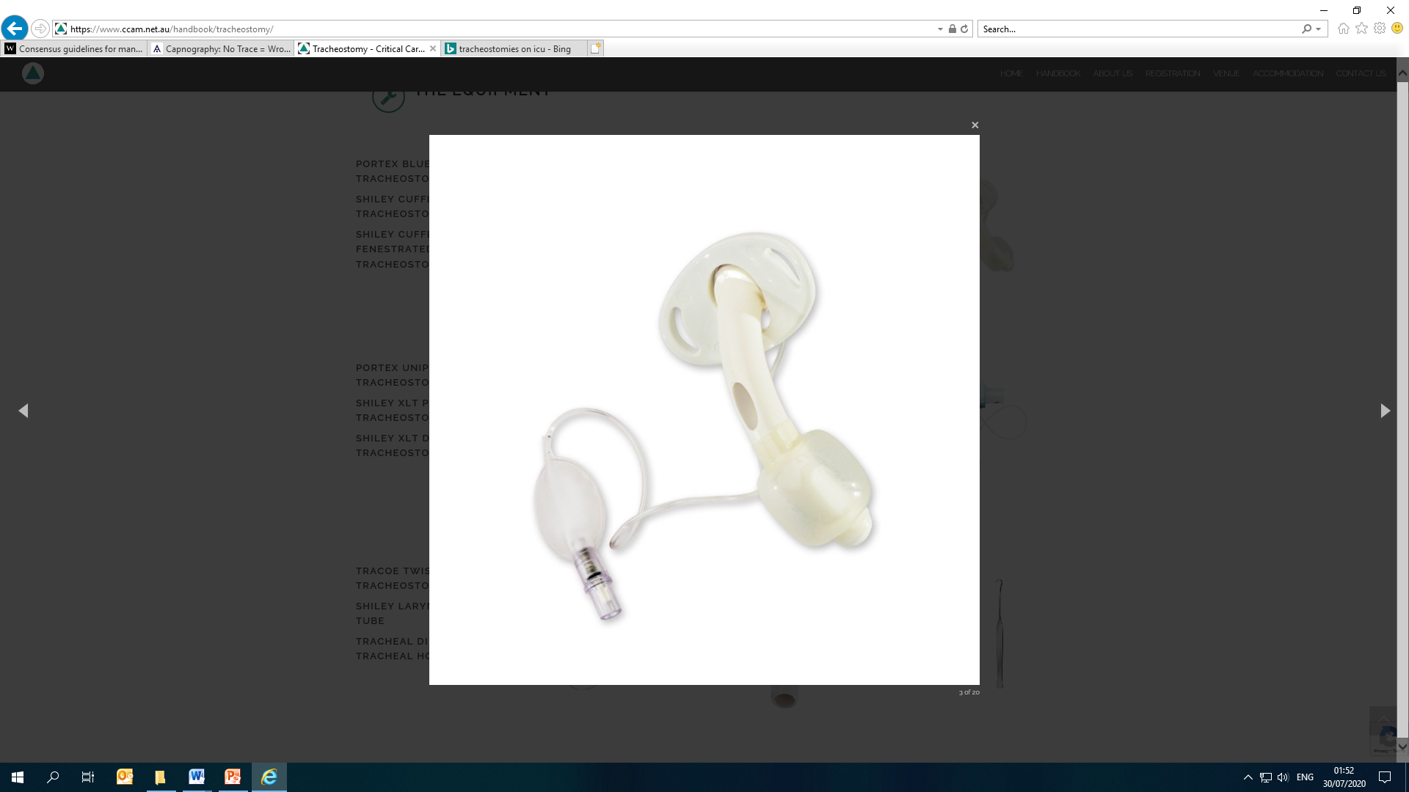

Trachesotomy tubes may have:
1. Cuff or no cuff
2. Inner tube or no inner tube
3. Adjustable flange
4. Fenestrations

Good resources for tracheostomy information are https://tracheostomy.org.uk/
https://www.ccam.net.au/handbook/tracheostomy/
https://www.e-lfh.org.uk/ Tracheostomy Safety

2. Breathing

2.1 Ventilation on ICU
There is no substitute to spending time on your unit, learning from the senior medical and nursing staff about ventilation. Each department has a different default ventilation strategy. However, there are basic principles of mechanical invasive ventilation that you should know, to be able to troubleshoot whilst on ICU.

If in doubt, ask for help!

Invasive Ventilation
Invasive ventilation requires the patient to have an artificial airway (usually oral/nasal endotracheal tube or tracheostomy tube) and be provided with positive pressure ventilation. There are many modes of invasive ventilation, but they all come down to two main ways of delivering a ‘breath’ to a patient:

- Volume control ventilation: delivery of a certain volume of gas to the patient. This will result in a variable peak pressure being applied to the patient’s airway, depending on patient, pathophysiology and equipment factors.
- Pressure control ventilation: delivery of gas under a certain pressure to the patient. This will result in a variable volume breath being delivered, depending on patient, pathophysiology and equipment factors.

Harm can be easily caused by invasive ventilation. We aim to avoid ventilator-associated lung injury by ventilating safely and appropriately:

- Barotrauma – injury caused by excess pressure.
- Volutrauma – injury caused by excess volume.
- Atelectotrauma – injury caused by the cyclic opening and closing of alveoli during tidal ventilation and mainly happens at the edge between normally aerated and collapsed lung zones.
- Biotrauma – trauma from inflammatory process triggered by the mechanical stress at the alveolo-capillary wall.
- Other harm: damage to airway, respiratory muscle weakness, haemodynamic compromise, oxygen toxicity (atelectasis, free radicals, neonates).

Ventilation terminology
Each manufacturer will have different terms for similar settings. The important thing is to understand the physiological basics.

FiO2
- fraction of inspired O2
- expressed as a decimal (0.6) rather than a percentage (60%)

PEEP (cmH20)
- positive end expiratory pressure
- the pressure left in lungs at end of expiration, keeping alveoli open
- PEEP allows alveoli to expand more easily during inspiration
- PEEP allows more time for O2 to diffuse across the alveolar membrane into the capillaries

Tidal Volume (mls)
- TV or V_{T}
- the volume of gas blown in and out of the lungs during a normal breath

- good evidence to show patients should be ventilated with a tidal volume of 6mls/kg of ideal body weight (6-8mls/kg max) – see Section 2.3 LPV

Inspiratory Pressure (Pinsp cmH20)
- pressure by ventilator given during inspiration
- given on top of PEEP

Peak Pressure (Ppeak cmH20)
- highest pressure reached during inspiration
- usually this is the sum of PEEP + Pinsp
- the difference in the pressure when going from expiration and inspiration dictates the volume of gas blown into the lungs ie TV
- on some ventilators/modes, Ppeak = Pinsp, meaning the additional pressure the ventilator has given in that breath (to inflate the lungs) is Pinsp – PEEP

Plateau pressure (cmH20)
- the pressure measured during an inspiratory pause (usually taken as the pressure applied to the alveoli)

Inspiratory to Expiratory ratio (I:E)
- the proportion of the whole respiratory cycle (breath) spent in inspiration compared with expiration
- usually around 1:2
- can be altered to improve oxygenation or ventilation (CO2 removal)

Mean airway pressure (cmH20)
- mean pressure in the airways during positive pressure ventilation
- contributes to oxygenation
- affected by PEEP, I:E

Pressure support (PS cmH20)
- pressure applied to assist patient during spontaneous breaths on the ventilator

Ventilation Modes

Volume Control (VC)
- set tidal volume is supplied by the ventilator
- the resulting inspiratory pressure is variable and dependent on changing lung mechanics.

Pressure Control (PC)
- two pressure levels are kept constant: the lower pressure level PEEP and the upper pressure level Pinsp.
- the resulting volume is variable and can vary dependent on changes in the lung mechanics.

Synchronised Intermittent Mandatory Ventilation (SIMV)
- set tidal volume and respiratory rate delivered
- patient can take spontaneous breaths during the expiration phase
- spontaneous breaths will be ‘supported’ by PS set to achieve an appropriate tidal volume.

Pressure Control Volume Guarantee (PC-VG)
- delivery of mandatory breaths to a set tidal volume but with the minimum pressure (as per PC ventilation)

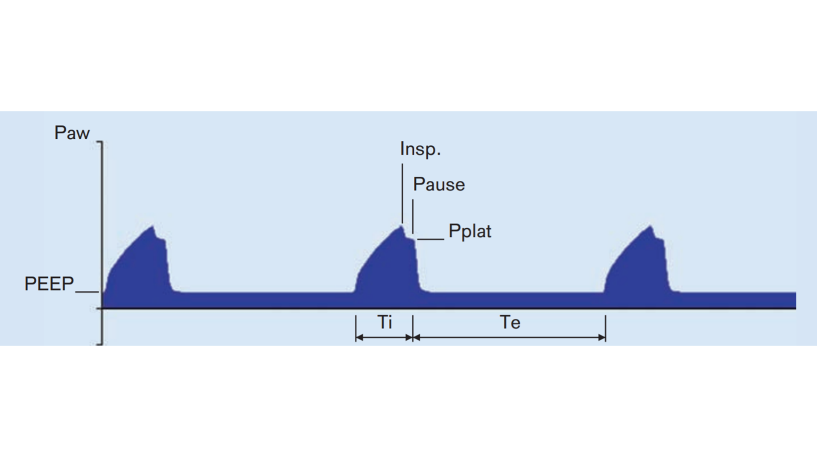

Further reading: https://www.draeger.com/library/content/rsp-new-nomenclature-ventilation-modes-icu-booklet-9066477-en.pdf

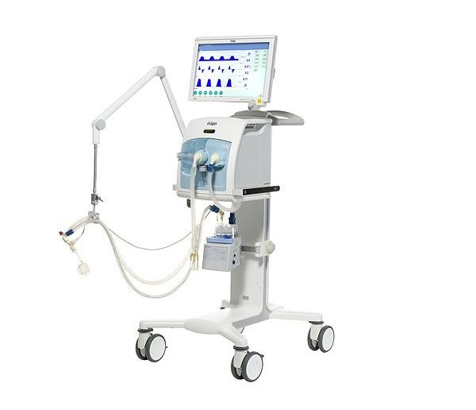

Ventilator Set Up

Components
- Inspiratory and expiratory limbs of ventilator tubing
- Inspiratory and expiratory valves
- +/- wet circuit humidification system
- Ventilator screen
4
- +/- viral filter on expiratory limb

2

3
1

Setting up a ventilator

1. Set up what you would like the patient to have:
- oxygen concentration
- tidal volume (in VC/PC-VG) or inspiratory pressure (PC)
- respiratory rate

These are what we are aiming to give the patient.

2. Monitor what the patient is receiving:
This is not always what has been dialled up as it is reliant on good sedation, patient synching well with ventilator and the ability of the ventilator to deliver these breaths which depends on patient size, position, pathology, sedation etc.

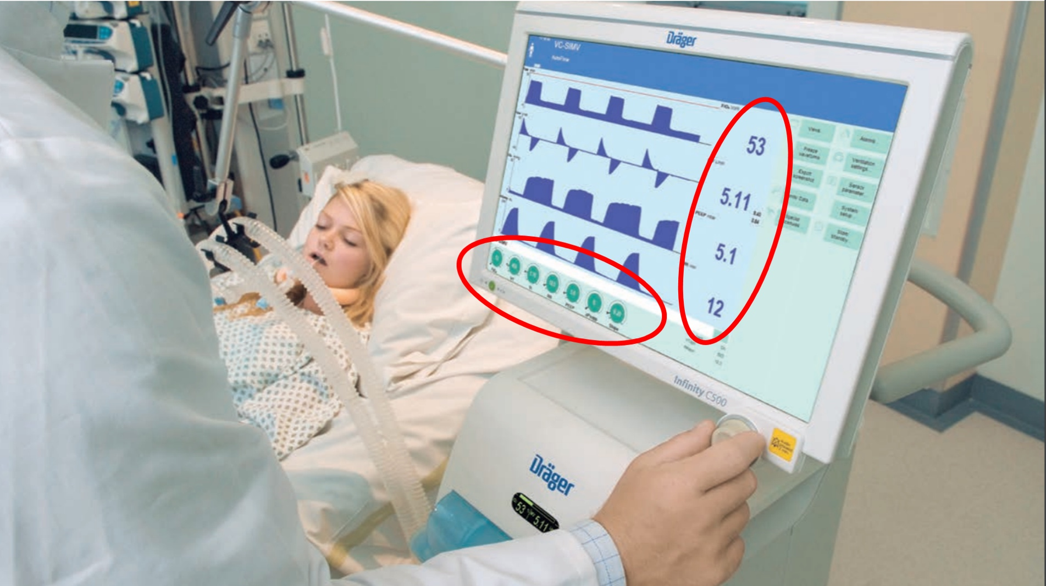

1

2

2.2 Improving Oxygenation and Ventilation

Increase Oxygenation | Increase Ventilation (CO2 removal)
Increase FiO2  Improve mechanics  Treat any underlying cause  Increase mean airway pressure:  Increase PEEP  Change I:E (increase I time)  Prone ventilation  ECMO | Consider increasing FiO2  Ensure correct TV (6ml/kg IBW)  Improve mechanics  Treat any underlying cause  Increase minute ventilation:  Increase RR  Change I:E (increase E time) to allow more breaths  Reduce production

2.3 Lung Protective Ventilation

Lung protective ventilation (LPV) is a strategy used to ventilate ICU patients, based upon research done around the management of ARDS (acute respiratory distress syndrome).

The main goals of LPV are
- Tidal volume 6 ml/kg based on ideal body weight (6-8ml/kg)
- Plateau pressure <30 cmH2O
- Permissive hypercapnia (higher PaCO2) tolerated as long as pH > 7.2
- PEEP increasing in line with FiO2: ARDSnet suggests the use of PEEP/FiO2 tables

Further reading:
1. ARDSNet
2. BJA article on ARDS
https://academic.oup.com/bjaed/article/17/5/161/3782744
3. ATOTW ARDS https://www.wfsahq.org/components/com_virtual_library/media/2ee4f27f10c91b341754032927d178cc-atow-411-00.pdf

2.4 Ventilator Care Bundles

The ventilator care bundle is a series of interventions designed to increase the safety of being on a ventilator. Some of these interventions reduce the risk of ventilator associated pneumonia (VAP).

Each region or department will have developed their own bundle but the main components are likely to be:

- Raised head of bed to 30-45 degrees (minimises microaspiration)
- Daily sedation holds to assess readiness for extubation (decrease length of stay)
- DVT prophylaxis (as patients are so ill and immobile)
- Peptic ulcer prophylaxis (reduces risk of GI bleed but necessarily mortality)
- Oral care such as oral chlorhexidine (minimises microaspiration)
- Use of tracheal tube with subglottic ports (minimises microaspiration)

3. Circulation

3.1 Arterial Line

3.1a Indications

- Continuous invasive blood pressure monitoring
- Repeated blood sampling: assess changes in ventilation, acid:base balance, glucose, anticoagulation

Only absolute contraindications to arterial cannula insertion
- Arterio-venous fistula
- Localised sepsis at insertion site

3.1b Types of lines:

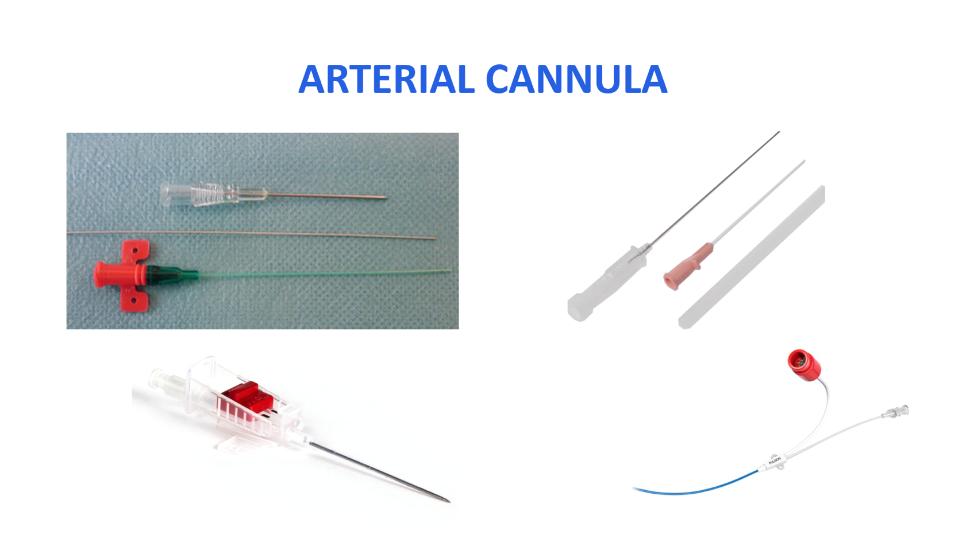
4
3
2
1
- Vygon: inserted using Seldinger technique
Good for long stay patients, seem to kink less but can be messy to insert. Use inco pads if you want to make the ICU nurses happy!
- Floswitch: inserted using cannula technique.
Less messy and reduced risk air embolism due to on-off switch.
Good for middle-length use.
- Abbocath: inserted using cannula technique.
Some people choose to transfix the vessel.
Easy to kink and will not ‘unkink’ so will often need replacing.
- PiCCO (Pulse Contour Cardiac Output monitoring): inserted using Seldinger technique
Arterial cannula with thermistor that can be used to monitor cardiac output by thermodilution studies or deriving parameters from shape of arterial waveform.

Insertion sites:
- Usually radial – may be difficult if very hypotensive
- Brachial – should use ultrasound
- Femoral – should use ultrasound, will need longer and wider cannula
- Dorsalis pedis

Insertion technique:
- Varies with type of cannula – seldinger vs cannula
- Helpful videos on e-Learning for Healthcare in Anaesthesia and Intensive Care Learning Modules

My e-Learning: Anaesthesia (e-LA) Core Training - Clinical
e-LA Module 03 - Introduction to Critical Care General ICU Care
Procedures Arterial line: indications, insertion, complications

My e-Learning: Intensive Care Medicine (e-ICM)
Module 6 Procedures, Investigations and Monitoring in ICM
01 Procedures 02 Vascular Access
Arterial Lines: Technique of Insertion

Whichever site you choose, and whichever cannula type you use consider the following:
- Take time to prepare patient and equipment correctly – inco pads will keep your ICU nurse happy
- Consider USS if poorly palpable pulses
- Local anaesthetic infiltration in awake patients
- Maintain asepsis: Chlorhexidine/isopropyl alcohol to skin, fenestrated drape, sterile gloves and plastic apron
- Ensure full documentation as per LocSSIP
ALWAYS ensure that the flush bag attached is 0.9% Sodium Chloride. The flush bag should never contain glucose.

A note on Allen’s test
- Used to confirm adequate ulnar artery circulation to maintain hand perfusion in event of trauma/thrombosis to cannulated radial artery
- Occlude both radial and ulnar artery for 1 minute, release and should see reperfusion of hand within 6 seconds
- No evidence to show positive correlation with actual perfusion or that it prevents ischaemia and most clinicians do not routinely perform it

3.1c Complications
EQUIPMENT RELATED
- Loss of guidewire if using seldinger technique
- Disconnection
  - At cannula or at transducer level
  - Can cause catastrophic haemorrhage if not recognized
- Incorrect flush solution: must be 0.9% NaCl or heparinised saline NOT dextrose
  - High index of suspicion if persistently high blood sugars on ABG despite insulin administration, potentially fatal never event
- Inadvertent intra-arterial injection: ensure good labelling as arterial line
MEDICAL
- Thrombosis
- Infection – less common than CVC infection but still possible
Distal ischemia

3.1d Troubleshooting
Arterial cannula is attached to an appropriate transducer system by a short length of manometer tubing. Continually flushed by pressurised 0.9% NaCl (NOT dextrose).

Ensure transducer is at correct height
- Level of 4th intercostal space (or at tregus for neuro patients)
- Transducer below the heart – falsely high arterial BP
- Transducer above the heart – falsely low arterial BP

What do we mean by ‘zeroing’?
- The system needs be calibrated to atmospheric pressure
- This is done by zeroing the system when the transducer system is turned “off to the patient but open to air” (use of three-way tap)

What do we mean by a ‘damped’ trace?
The response in the system is too slow – can be caused by clot forming
- Ensure system flushes easily
- Ensure no air bubbles in tubing
- Ensure flush bag correctly pressurized
- Ensure cannula not kinked

If problems persist despite these simple checks then seek senior advice

A flat arterial line trace may be an erroneous reading but never assume this:
- Look for other signs of adequate circulation: heart rate and rhythm, ETCO2, NIBP, palpable pulses

3.2 Central Venous Line
For detailed instructions- see the CVC insertion guide on the New2ICU website.

3.2a Indications
IV access
- Patients on ICU require multiple drugs (often by infusion) simultaneously for long periods of time
- Often have poor peripheral access
- Many drugs given on ICU are unsuitable for peripheral administration
- Inotropes and vasoactive drugs can cause localized necrosis
- TPN and hyperosmolar fluids cause phlebitis

Therapeutic care
- Enable renal replacement therapy, plasma exchange, transvenous pacing

Monitoring pressures
- CVP rarely used as an isolated number but trend can be used to monitor progress
- More relevant in cardiac re: tamponade, right heart failure
- Measuring central venous oxygen saturations (ScvO2) to measure oxygen flux – balance between oxygen delivery and consumption
- Thermodilution techniques for measuring cardiac output

General points for all line insertions:
- Follow local policies and guidelines
- Use ultrasound for all central access, and for arterial lines if needed
- Choose best site before starting, to reduce number of attempts

3.2b Types of lines:

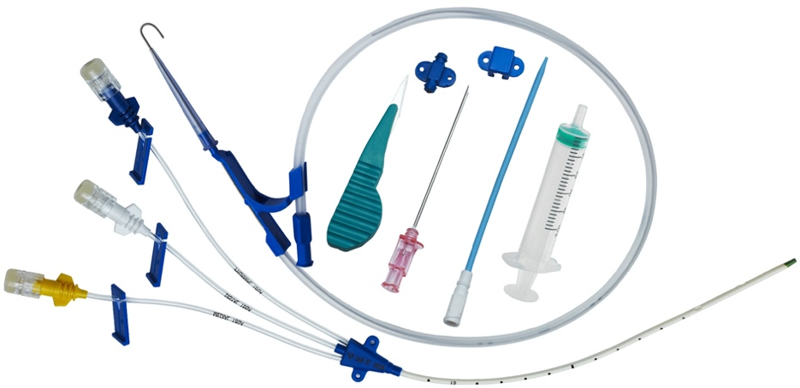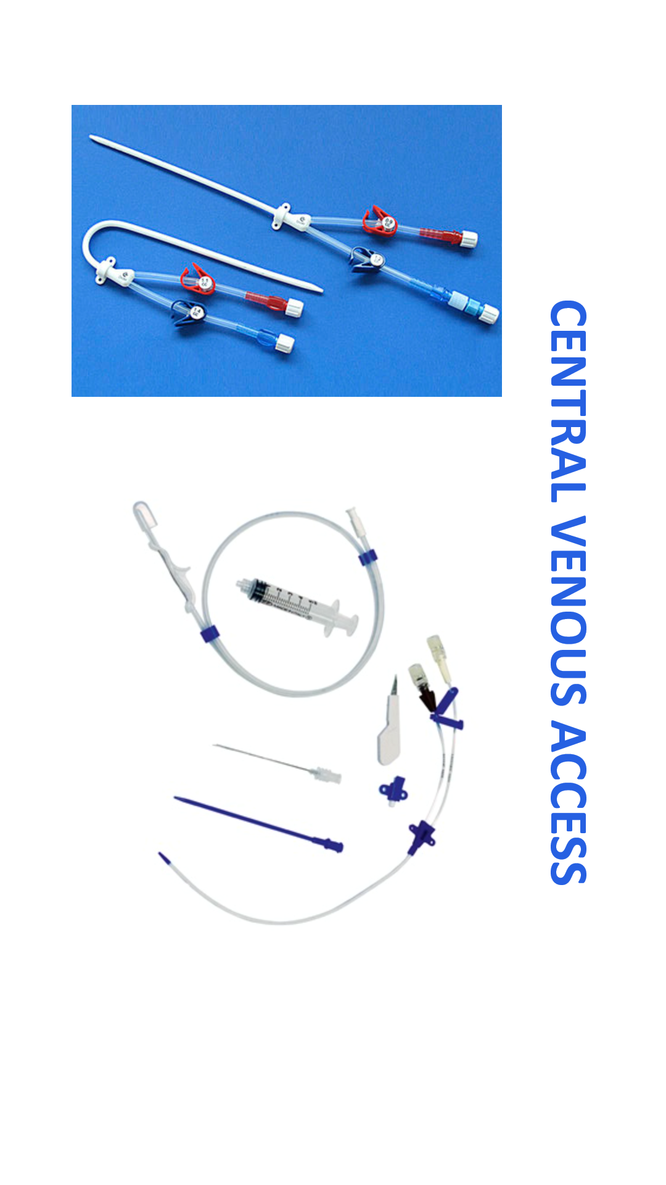
2
1

- Standard central line (7Fr) – usually 3-5 lumens, 16cm or 20cm length
- Vascath (14.5Fr) – two lumens, 16cm or 20cm length

Use a checklist. The national CVC insertion checklist is available on the New2ICU website and is shown below²

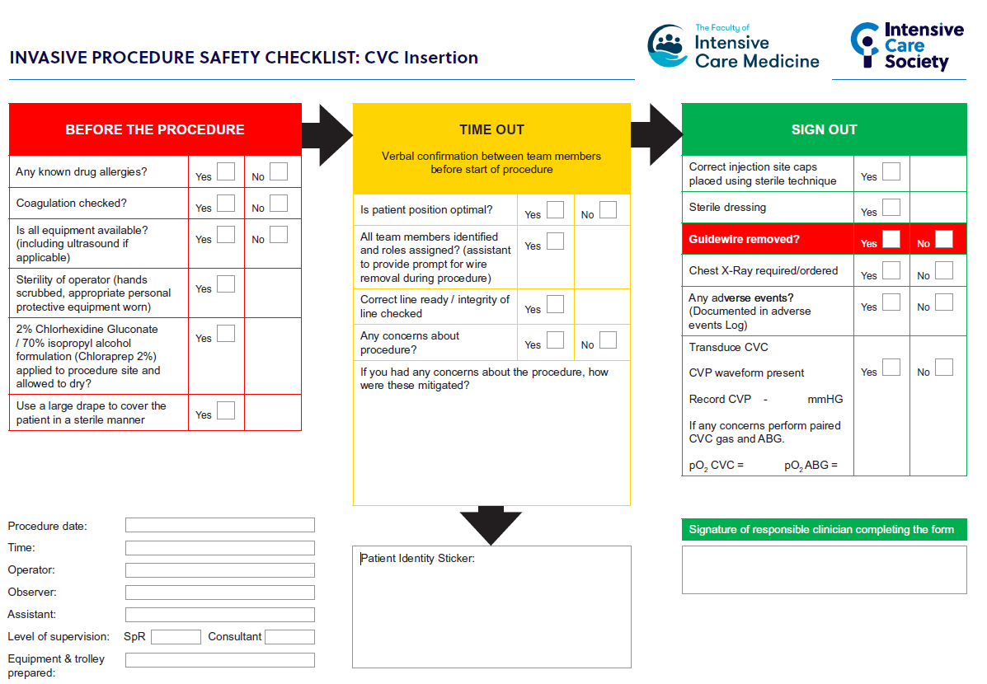

3.2c Insertion sites:
- Internal jugular - most commonly used, right sided is usually first choice
- Femoral – higher infection risk, difficult in obese patients
- Subclavian – lower infection risk, technically more challenging to insert, difficult to compress in case of inadvertent arterial puncture
Use ultrasound for all central line insertions

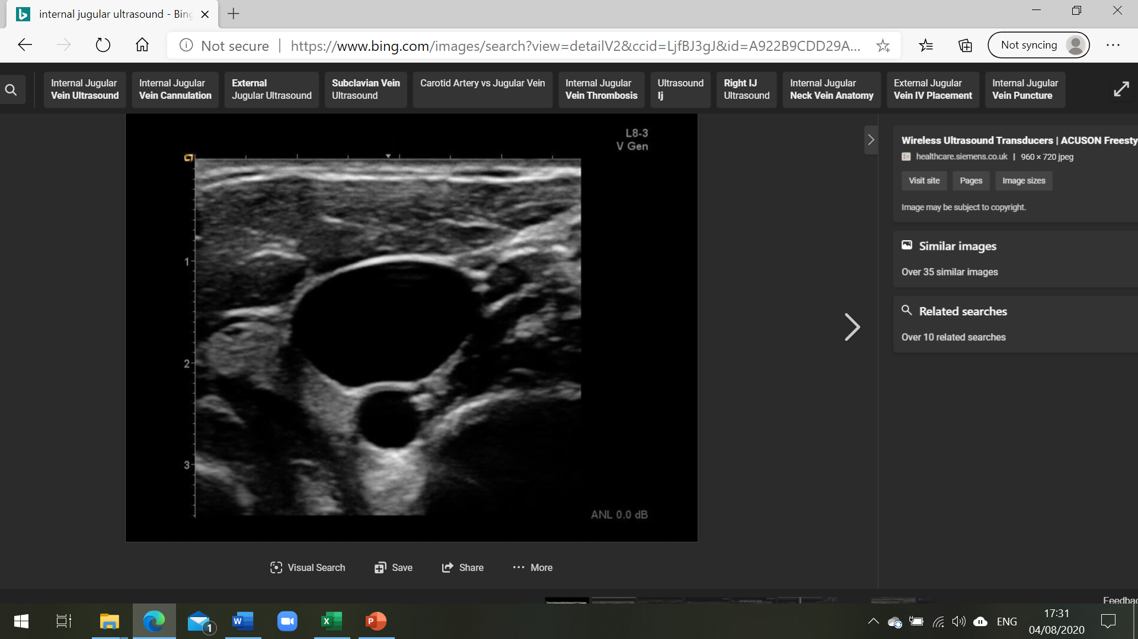
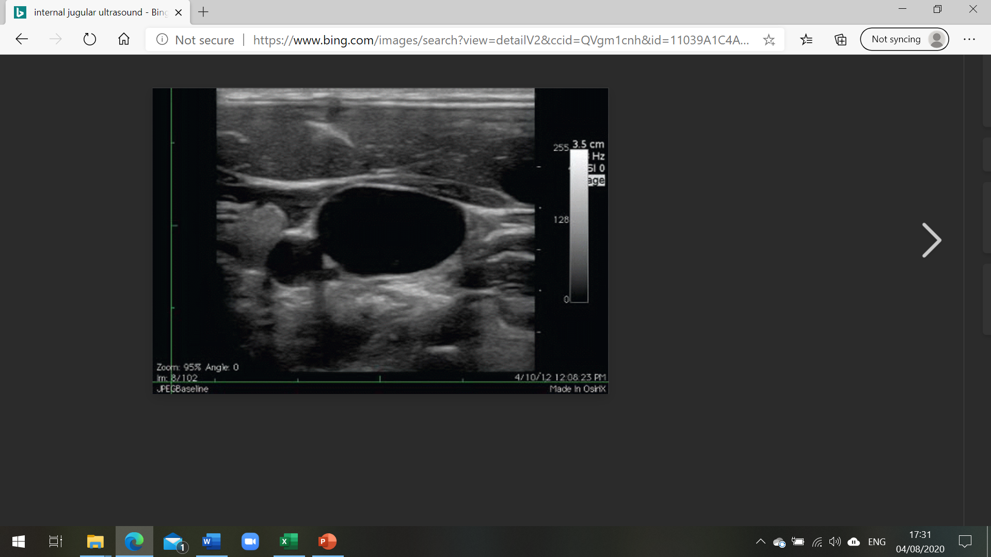
US image of right internal jugular vein (1), and carotid artery (2).
1
1
2
2

Image 1 Image 2

Use ultrasound to find the best picture: aim to get the carotid to the side of the internal jugular (image 2), rather than below it (image 1).

Visualise your needle tip on the US image.

ALWAYS ensure that the flush bag attached is 0.9% Sodium Chloride. The flush bag should never contain glucose.

Whichever site you choose, and whichever line you use consider the following:
- Take time to prepare patient and equipment correctly – inco pads will keep your ICU nurse happy
- Always use USS (exception: subclavian lines)
- Local anaesthetic infiltration in awake patients
- Maintain sterile conditions: Chlorhexidine/isopropyl alcohol to skin, fenestrated drape, sterile hat, mask, gown and gloves, US probe cover.
- Ensure transducer and flush line all ready to go before you start procedure
- Ensure full documentation as per LocSSIP (including pre-procedure checks)

3.2d Complications
EARLY
- Arrhythmias
  - At time of insertion – usually due to myocardial irritation by guidewire and resolve on withdrawing wire, if persist line may be too far in
- Arterial puncture
  - USS minimizes risk
  - Usually obvious – transducing line/blood gas will confirm
  - Needs 5-10 min compression
- Pneumothorax
- Bleeding - at insertion site
- Nerve injury – rare
- Air embolism – head down position minimizes air entrainment as venous system engorged
LATE
- Thrombosis
- Pericardial tamponade – rare, due to atrial puncture if line too far in
- Infection – consider removing all lines when no longer required, monitor site, be aware of duration since insertion

You have an important role in helping to manage lines and minimise complications
- Diligent asepsis if accessing line
- Assessment of invasive lines forms part of daily check on ICU
- Ensure you know how long the line has been present and examine site, ensure needle free access on all lumens
- Lines do not have to be changed after a certain amount of time. If the site looks infected and/or there are raised inflammatory markers, then consider the line as a source of infection
- If concerns regarding line sepsis they must be removed
- Know how to assess correct position on CXR
- Be familiar with difference between arterial and CVP waveform so you feel comfortable that line is correctly sited
- If called to assess CVC because 1 or more lumens not aspirating or flushing freely then label blocked lumen and seek senior advice
- If a dedicated lumen has been labelled as for TPN then this lumen should not be used for anything else
- CVCs can leak around their insertion site. If asked to review, ensure patient appears to be stable from a haemodynamic and sedation point of view, and discuss with senior for further advice.

3.2e Central Line Care Bundle
- Surgical scrub hand hygiene, gown, gloves, hat, mask.
- 2% chlorhexidine in alcohol for skin antisepsis
- Maximal barrier precautions before insertion
- Optimal catheter site (subclavian is lowest risk, avoid the femoral route)
- Aseptic access technique
- Daily review of central line necessity with prompt removal of unnecessary lines
- Education

Always follow local protocols and document clearly (the national checklist has a second page with appropriate documentation, but your unit will have its own way of documenting insertion.

3.2f Confirming Central Venous Line Position
Four important aspects to confirming correct position of CVL:

1. Use of ultrasound to confirm guidewire in the vein during insertion
2. Venous blood gas taken immediately after insertion of line
3. A transduced venous waveform with appropriate pressure (usually 0-20mmHg)
4. Correct position on a CXR (if placed via the internal jugular or subclavian vein)
- CVL tip should be in the SVC
- Ideally level with the carina

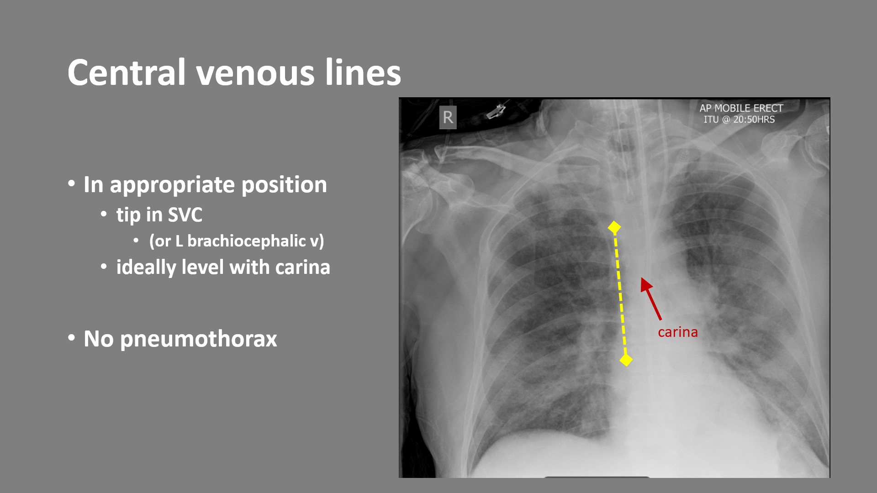

4. Sedation and Delirium

4.1 Sedation drugs on ICU

There are many reasons patients are sedated on ICU, and the reasons for sedation help us to decide which drugs to use. Each ICU will have their own protocols so you should become familiar with that, but the basics of the main drugs used can be found in section 5.

Commonly used drugs include:

Sedation: Propofol, Midazolam, Clonidine, Dexmedetomidine
Analgesics: Alfentanil, Morphine, Remifentanil
Adjuncts: Quetiapine, Haloperidol, Melatonin, Amitriptyline, Ketamine
Muscle relaxants: NOT SEDATION but used alongside appropriate sedation
Rocuronium, Atracurium

4.2 Role of sedation

- Placement and tolerance of endotracheal tube
- Facilitate mechanical ventilation and improve compliance
- Reduce oxygen consumption
- Enable procedures and critical care to be delivered
- Maintain comfort/humanitarian
- Control of raised intracranial pressure
- Management of neurological disturbance (seizures, agitation)

Despite appropriate use, sedation can have significant adverse effects. These include:

- Prolonged mechanical ventilation and ICU stay
- Critical care weakness/myoneuropathy
- Cardiovascular instability
- Reduced ability to assess neurological function
- Delirium

4.3 Management of sedation

Appropriate management of sedation is essential to reduce the above adverse effects. The general consensus is minimizing sedation where possible, is preferable for most ICU patients.

General concepts in sedation management include:
- Daily assessment of sedation levels (see scoring system below)
- Daily sedation breaks (interruption in sedation or ‘sedation hold’)
- Advancement of ICU care to enable sedation weaning (ie tracheostomy)

Sedation Assessment
- The most commonly used scoring system is the Richmond Agitation-Sedation Score (RASS)³
- Score from -5 (unrouseable) to +4 (combative)
- Aim for ideal sedation is -2 to 0 for most ICU patients, although certain patient groups require deeper sedation (proned patients, patients with raised ICP)
- Sedation aims should be discussed and documented daily on ward rounds

Score | Term | Description
+4 | Combative | Overtly combative or violent, immediate danger to staff
+3 | Very agitated | Pulls to remove tubes or catheters, aggressive behaviour toward staff
+2 | Agitated | Frequent non-purposeful movement, fights ventilator
+1 | Restless | Anxious, apprehensive, not aggressive
0 | Alert and calm | Spontaneously pays attention
-1 | Drowsy | Not fully alert, but has sustained awakening, with eye contact, to voice (more than 10 seconds)
-2 | Light sedation | Briefly awakens with eye contact to voice (less than 10 seconds)
-3 | Moderate sedation | Movement, but no eye contact, to voice
-4 | Deep sedation | No response to voice, but movement or eye opening to physical stimulation
-5 | Unrouseable | No response to voice or physical stimuli

Sedation Holds
These should be done daily, when medically appropriate, and ideally at the beginning of the day. They should be discussed on the ward round.

The possible benefits of sedation hold include:
- Decreased ventilator time
- Decreased length of stay
- Decreased use of vasoactive drugs
- Increase likelihood of successful extubation / decreased risk of tracheostomy
- Decreased delirium and psychological adverse effects

They should be done with caution as there is a risk of accidental or unplanned self-extubation or removal of lines/tubes/drains. They also significantly increase nursing workload.

4.4 Delirium on ICU

Definition: a disturbance of consciousness with inattention accompanied by a change in cognition or perceptual disturbance that develops over a short period of time and fluctuates over time. Inattention is one of the hallmarks and pivotal features of delirium.

Delirium on ICU is very, very common (affecting up to 80% of ICU patients). It increases morbidity and mortality and has significant effects on the patient’s long- term recovery.

There are three types of delirium
- Hyperactive: agitation, restlessness, aggression, removal of tubes/lines
- Hypoactive: withdrawal, flat affect, inability to engage, lethargy, decreased responsiveness
- Mixed: fluctuation between hyper- and hypoactive delirium

Hypoactive and mixed are most common on ICU, although can be hardest to recognize.

Assessment of delirium
- Maintain high index of suspicion in all patients
- Identify risk factors present in each patient
- Formally assess at least daily

Risk Factors for delirium:
- Pre-existing factors: age, cognitive impairment, alcohol/drug/nicotine use, hypertension, emergency admission
- ICU factors: increased severity of illness, mechanical ventilation, metabolic acidosis, coma, sepsis, steroids, benzodiazepines

Formal assessment of delirium is undertaken using the Confusion Assessment Method for the ICU (CAM-ICU) scoring tool:

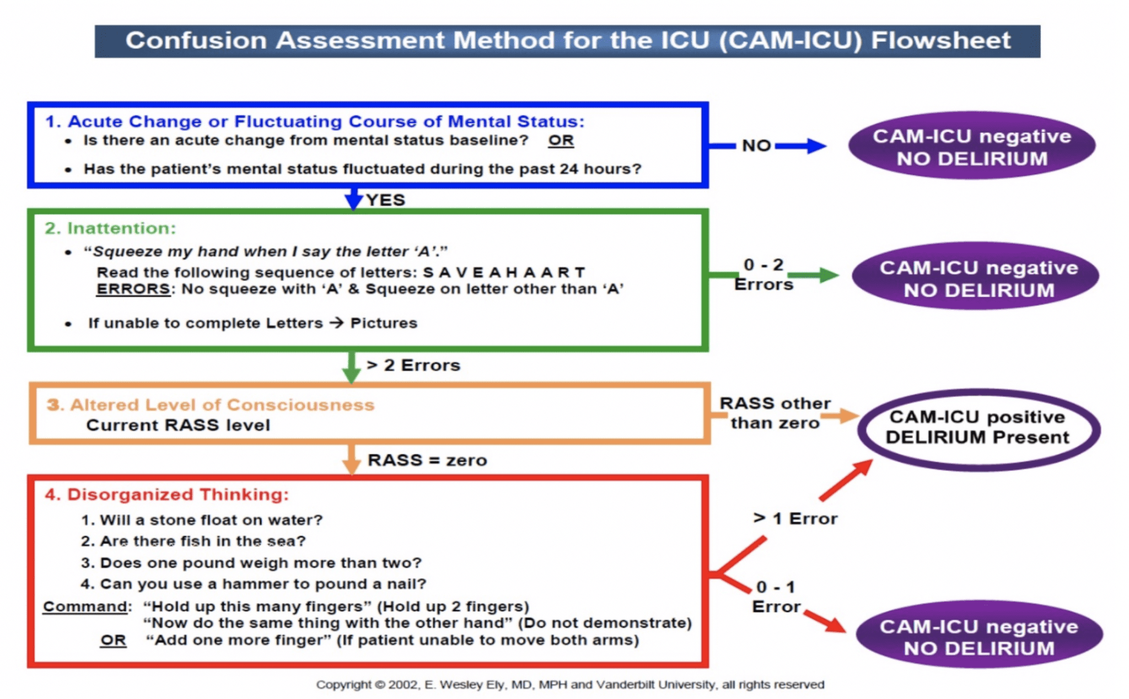

4.5 Management of delirium on ICU

Management of delirium is incredibly hard and very different to ward patients. Hyperactive delirium with agitation and pulling out of tubes and lines can be fatal in ICU patients, and therefore we may move to pharmacological or restraint management strategies earlier than you would on the ward. However, we try not to sedate people unless necessary as otherwise our patients will never get better.

Non-pharmacological measures for prevention and management of delirium:
• Daily assessment using bedside tools (CAM-ICU)
• Repeated reorientation of patients
• Provisions of cognitively stimulating activities for the patient multiple times a day
• A non-pharmacological sleep protocol: lights down, alarm volumes reduced, eye mask, ear plugs (and ask patient what is effective!)
• Early mobilization activities
• Timely removal of catheters and physical restraints
• Use of eyeglasses and magnifying lenses, hearing aids and earwax removal
• Early correction of dehydration
• Use of a scheduled pain management protocol
• Minimization of unnecessary noise/stimulation/observations
• Ask patients each day if any concerns with hallucinations, confusion etc
• Explain it to family and encourage engagement with above

Pharmacological measures for prevention and management of delirium:
• Review current medications
▪ Remove daytime sedation agents
▪ Review opioid analgesia
▪ Review anticholinergic drugs
• Use of non-opioid analgesia
• Avoid benzodiazepines
• Melatonin
• Short term Zopiclone for sleep

Medications for treatment:
• Haloperidol: for rescue: 0.5 – 2mg IV bolus (every 5 mins, up to 20mg)
• Quetiapine: commence if patient reports hallucinations or if rescue therapy used
consider evening only initially so as not to sedate during day
start at 25mg at 1800 or BD

Other medications used on ICU for light-moderate sedation, management of delirium and aiding sedation weaning:
• Clonidine
• Dexmedetomidine
• Remifentanil

5. Drugs on Intensive Care

5.1 Intensive Care Drugs and Pharmacology

Sedative Drugs

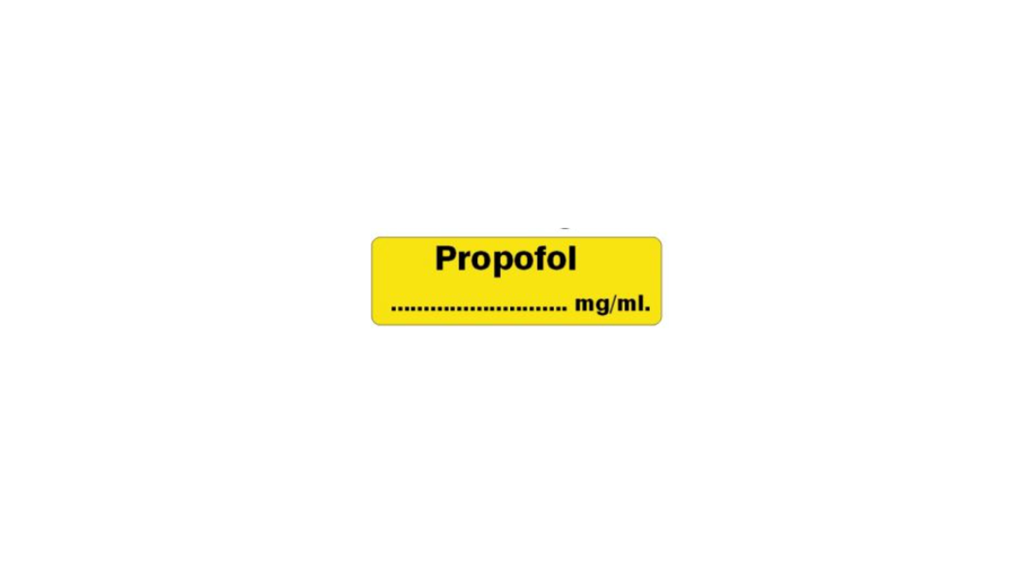 | Propofol  - Sedation for intubation and on ICU  - Given as bolus or infusion  - Two concentrations (1% 10mg/ml and 2% 20mg/ml)  - Infusion rates very variable but usually maximum around 300mg/hr  - Initial bolus dose for additional sedation 10-20mg  - Causes severe hypotension in very sick patients  - Can cause Propofol Infusion Syndrome with prolonged infusions (>48 hours) at >4mg/kg/hr  - COVID-19 patients needing many days of deep sedation and the move has been to using midazolam instead (currently Propofol in short supply nationally)
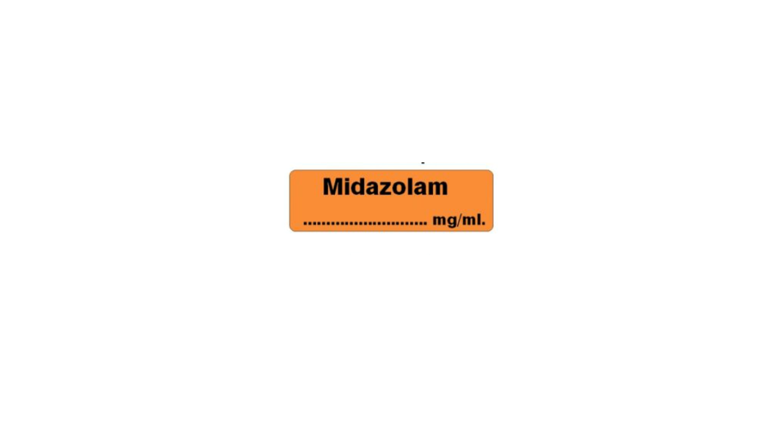 | Midazolam  - Sedation on ICU, and for ongoing seizures  - When given as prolonged infusion in ICU, will take a lot longer to wake up from vs Propofol  - Previously used as an adjunct in adult ICU, but with COVID drug shortages, has now become first line sedative in some units  - Increases delirium

Sedative Adjuncts

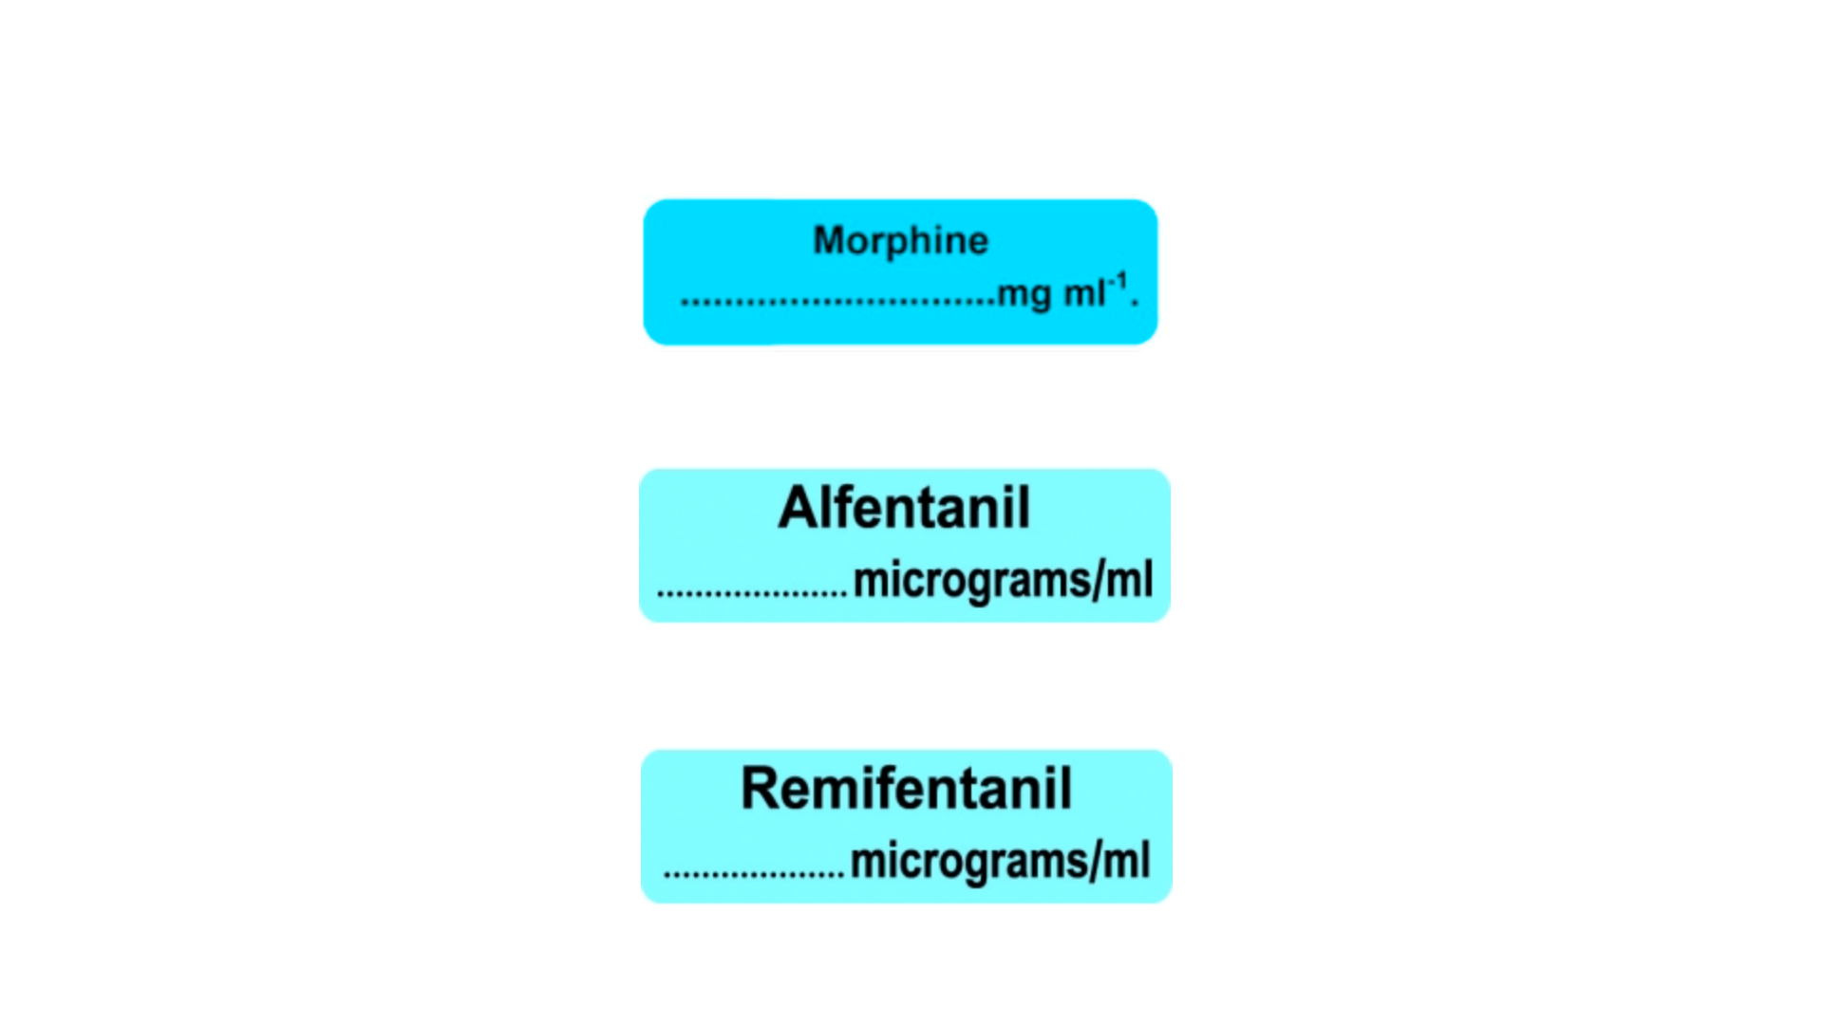 | Opioids: Commonly used as part of sedative regimen to reduce the amount of sedating agent required  - Can all cause bradycardia  - Can all cause respiratory depression – this may be beneficial to facilitate ventilator synchrony  Morphine  - Long acting (slow onset and offset)  - Less titratable  - Previously not used due to length of action, but now used more due to COVID drug shortages  Alfentanil  - More titratable than Morphine with good effect from bolus  Remifentanil  - Very quick onset and offset  - Used for light sedation with NIV/delirium/pre-extubation  - Should not be bolused
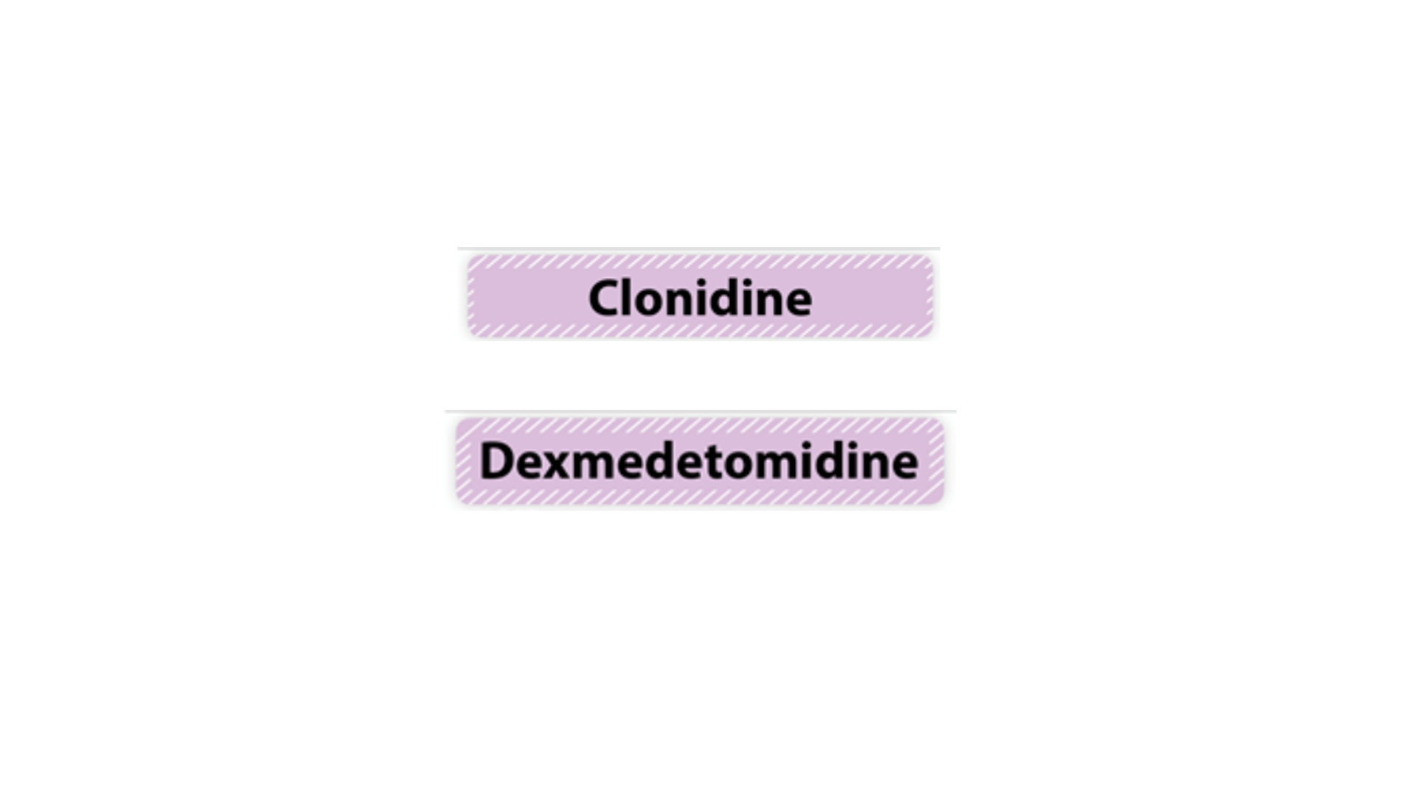 | α2 agonists: have analgesic, sedative and anxiolytic properties, can cause hypotension  - Good for patients with/at risk of alcohol withdrawal, weaning from long-term ventilation.  - Reduce delirium compared to benzodiazepines  Clonidine  - Can be given as bolus or infusion  - Can be given IV or enterally  Dexmedetomidine  - Very expensive – consultants only  - Given as IV infusion  - Needs to be uptitrated to effect

Neuromuscular blocking agents

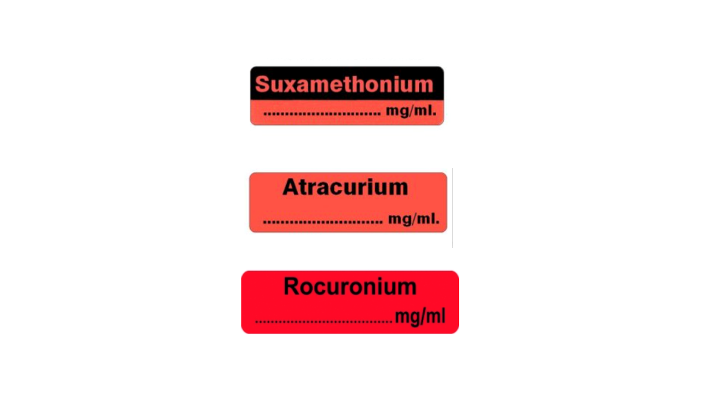 | Muscle relaxants: should only be used once appropriately sedated  Used for the following reasons:  - Intubation  - Synchronisation with ventilator, improving ventilation  - Prior to proning to prevent coughing/movement that could cause accidental extubation  All have significant potential adverse effects  Suxamethonium  - Caution in critical care patients  - Only used as bolus  Atracurium and Rocuronium  - Given as bolus or infusion  - Rocuronium used for intubation in ICU patients  - Prolonged infusions can contribute to critical care neuromyopathies

Drugs used for intubation on ICU

Sedative: Ketamine 1-2mg/kg (caution with different concentrations)
Propofol with caution and as directed by senior, due to risk of severe hypotension and cardiovascular collapse

Opioid: Fentanyl 1-3mcg/kg or Alfentanil as directed by senior
Optional depending on patient’s physiological status

Muscle relaxant: Rocuronium 1mg/kg

Emergency: Metaraminol 0.5mg/ml (10mg into 20ml)
Adrenaline 10mcg/ml

You may hear the term “3:2:1” when discussing emergency drugs. This refers to pre-hospital protocol of 3mcg/kg Fentanyl, 2mg/kg Ketamine and 1mg/kg Rocuronium. This can be adapted to 1:1:1 in very haemodynamically unstable patients.

3:2:1 has been adopted widely in hospital as well, although you may see variations on this with different seniors and different scenarios.

Suxamethonium is rarely used as a muscle relaxant in critically unwell patients due to:
- Risk of hyperkalaemia
- Risk of desaturation with muscle fasciculations
- Shorter-lasting intubation conditions which complicates a difficult airway
- Lack of benefit of ‘quick reversal’ in patients who are critically unwell.

Sugammadex should be available when using Rocuronium.

Cardiovascular Drugs

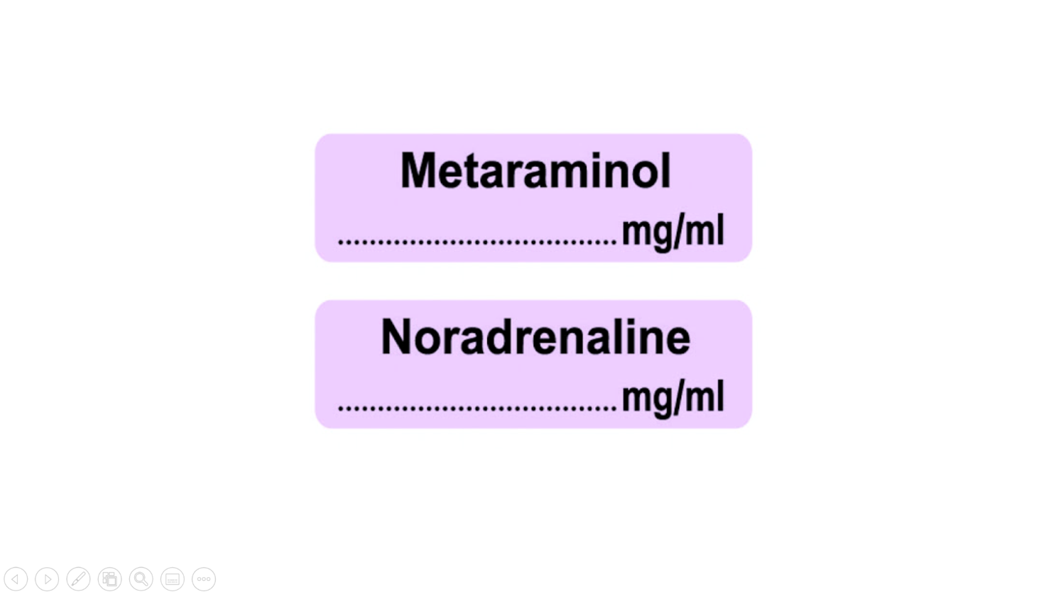 | Vasopressors: increase blood pressure by ‘squeezing’ (increasing peripheral vascular resistance)  Metaraminol  - Can be used peripherally  - Can be bloused 0.25mg – 0.5mg  - Often used initially in theatre / resus  - Usually diluted to 0.5mg/ml but can get pre-diluted ampules so be cautious  Noradrenaline  - Should always be used centrally  - Should never be given as a bolus  - Only used if CVL in-situ and checked position (venous gas, CXR)  - Should have two syringes attached, and requires double pumping  - Used in ml/hr but should consider what is ‘a lot’ by conversion to mcg/kg/min  - Be aware of different ‘standard’ preparations in Bristol (usually 4mg/50ml ‘single strength’ or 8mg/50ml ‘double strength’)
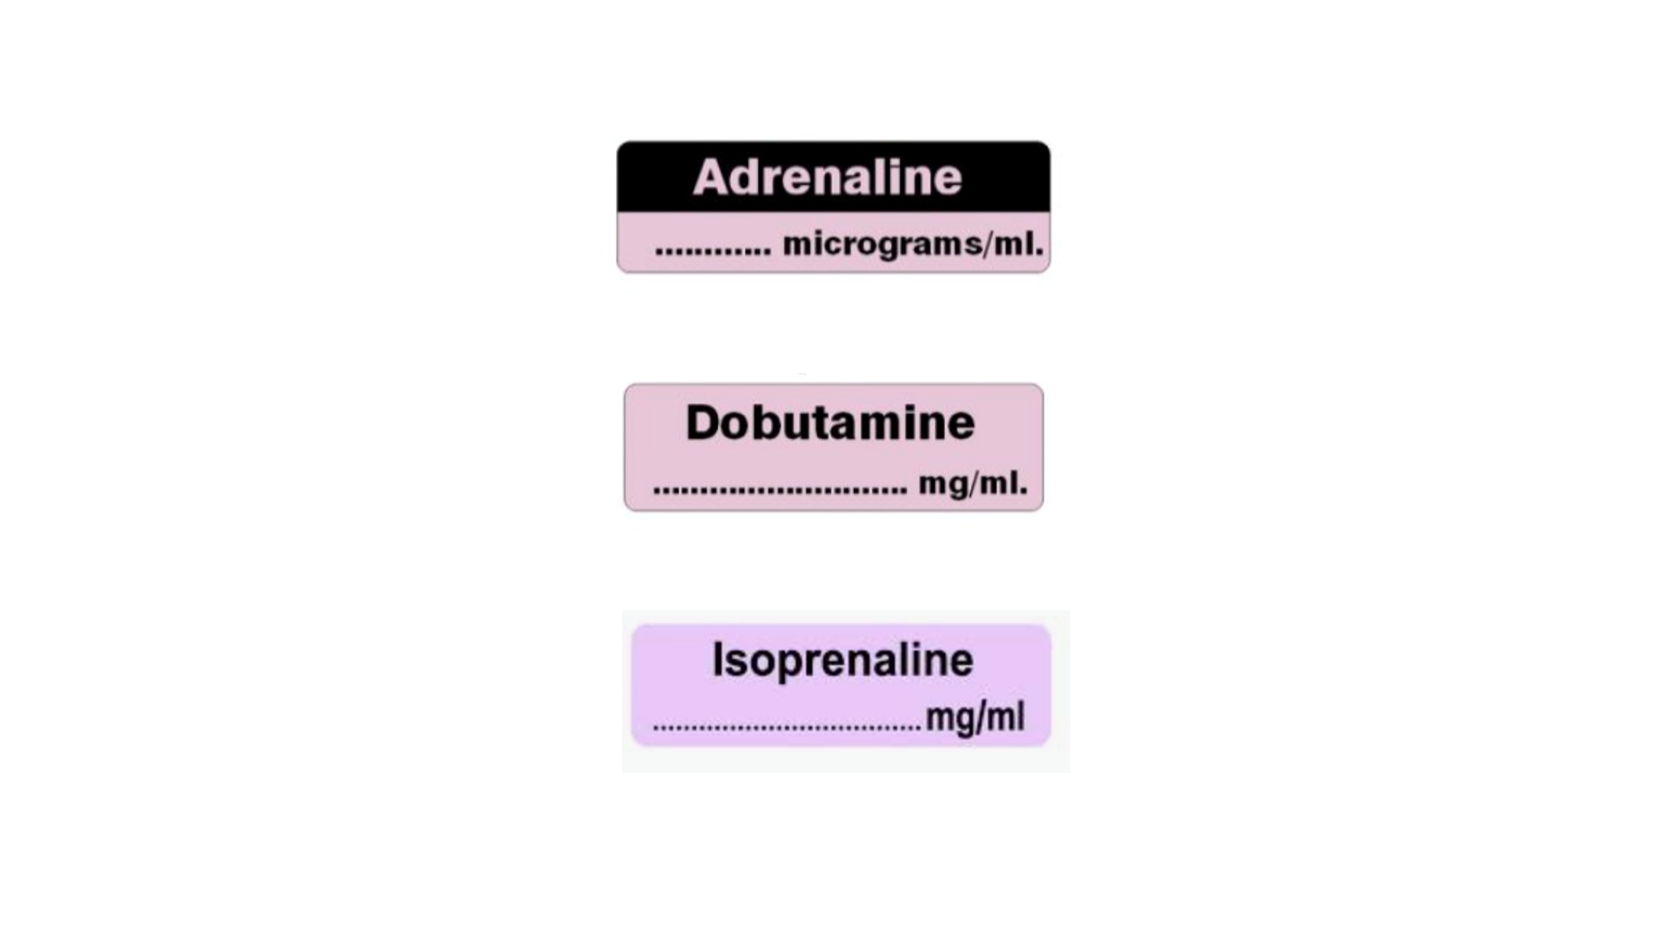 | Inotropes: increase cardiac output (heart rate and contractility), sometimes peripheral vascular resistance  Adrenaline  - Causes vasoconstriction  - Can be used peripherally (in the short term)  - Can be given as bolus, but outside of cardiac arrest only by people with experience (for BP support)  - Comes in multiple different concentrations and preparations so be very careful  - If someone asks you to give adrenaline bolus clarify the concentration and how much they want you to give  Dobutamine  - Causes vasodilatation  - Must be used centrally  - Used in cardiogenic shock/cardiac patients  Dopamine  - Causes vasoconstriction  - Not commonly used in adult intensive care – more commonly used in paediatric setting  Isoprenaline  - Can be used peripherally or centrally in treatment of heart block or severe bradycardia  - More of a CCU drug – in ICU we mainly use Dobutamine or Adrenaline
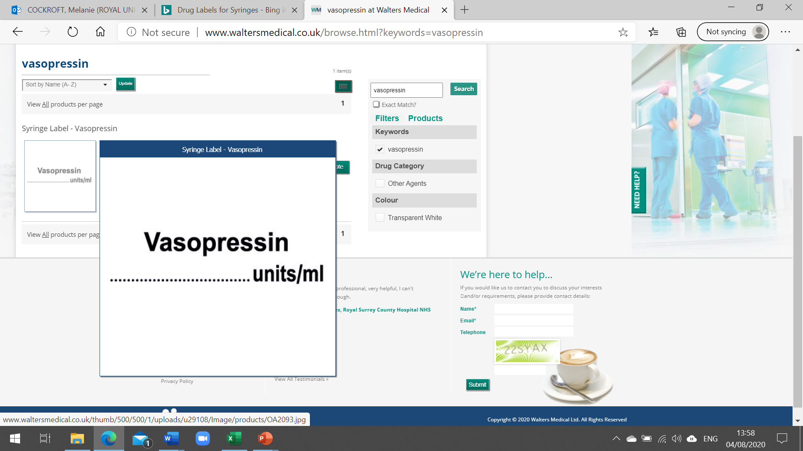 | Vasopressor: increase blood pressure by ‘squeezing’ (increasing peripheral vascular resistance)  Vasopressin  - Used in patients with refractory vasodilatation  - Continuous infusion of up to 0.04units/min  - Allows reduction in other vasopressors such as noradrenaline  - Not titrated as acutely as Noradrenaline
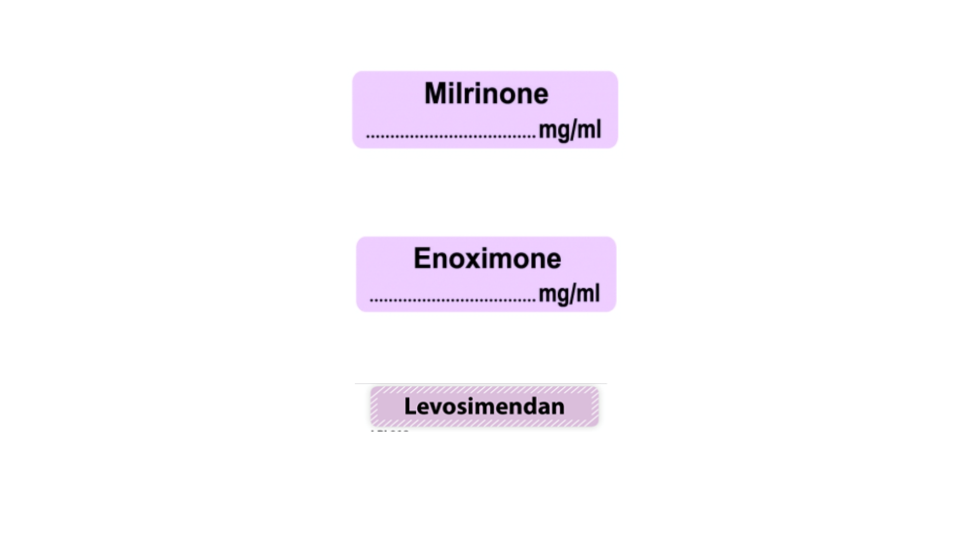 | Inodilators: drugs to increase cardiac output which cause vasodilatation  - Started by consultants only

6. Fluids, Feeding, Infection and Bundles, VTE

6.1 Fluids and Feeding

IV Fluids on ICU
Fluid balance assessment in critical care patients is often incredibly difficult. A thorough assessment of the patient should be made to help guide fluid management. A few general points should be considered when prescribing fluid on ICU:

1. Most ICU patients do not require background IV fluids (ie 8 hourly bags)
- Whenever possible, they should get their fluid requirements from their enteral feed
- IV drug infusions and regular medications provide a significant fluid load

2. Fluid bolus administration is more appropriate for ICU patients, when required

3. Critically unwell patients have different volume goals over their illness
- Often require some volume resuscitation
- Patients with chest or cardiac pathology are often poorly tolerant of fluid bolus
- COVID patients need more volume resuscitation than patients with other significant respiratory illness
- In their ‘recovery’ phase, patients can be limited in their ventilatory or mobility progress by fluid overload

4. Different fluids contain different electrolytes!
- Fluids with higher sodium (Na) content are often more appropriate in Neuro patients
- Always review dilutents used in patients with persistent Na or glucose abnormalities and consider changing if appropriate

5. Blood products are often appropriate to use
- Human Albumin Solution (20% or 5%) often used (under senior guidance)
- Blood transfusion threshold usually 70mg/dL but different in specific patient populations, eg cardiac, paediatric, trauma and haematology patients.

Feeding on ICU
Enteral feeding should be established as soon as appropriate in ICU, preferably via a nasogastric tube. However, it is rarely an acute life-saving treatment, and therefore should only be commenced when safe to do so.

Enteral feed
- Should be increased as per protocol
- Bedside Nurses will record ‘aspirates’ or ‘residuals’ and this will guide how well a patient is absorbing their feed.
- Most critically unwell patients with well-established feeding will require insulin (usually given as a variable rate infusion)

If NG feeding is not established, options include
- Prokinetics: IV Metoclopramide (1st line), IV Erythromycin
- Laxatives
- Insertion of NJ tube

Gastro-protection should be considered and prescribed for all patients who do not have full gastric feeding established:
- PPI: IV or enteral depending on absorption
- ‘Trophic’ feeding: 5-10mls/hr into NG in patients with NJ/parenteral feeding

Remember: nutritional supplements
- Pabrinex, vitamin / protein supplementation

Parenteral Feeding
- Does not usually need to be established early (often considered about day 7)
- Should continue to try to feed enterally, if appropriate
- Prescribing and alterations led by ICU Dietician

Nasogastric tubes on ICU
There is significant morbidity and mortality attached to NG tubes on ICU.
There have been several misplaced NG tubes in this region over the last five years, where feeding has been commenced

Please ensure:
- You do the local and regional e-learning that is required regarding NG tube insertion
- You find out what your unit’s guidelines say about who is able to confirm positioning of NG tube
- You do not confirm correct position of a tube out of hours, unless it is required for life-saving drugs
- ALWAYS use a systematic approach to check NG CXRs, and document it clearly in the patient’s notes.

6.2 Infection and Bundles

Local Guidelines and Micro services
- Always follow local guideline when commencing antimicrobial therapy
- Most ICUs will have a daily micro ward round to discuss therapy and escalation options
- Each unit will have their own protocols regarding frequency of sampling, thresholds for sampling, the use of Procalcitonin (PCT)

General infection control measures used on ICU
- Aprons and gloves required when entering patient’s bedspace at all times
- Don’t use your own stethoscope – each bed should have one
- Follow care bundles (see below) and LocSSIPs

- Airway: use of subglottic suction ports, regular mouth hygiene and inline suction
- Breathing: VAP prevention bundle
- Circulation: central line insertion LocSSIP and care bundles, coated lines, biopatches, aseptic technique when sampling from lines
- Gastro: good gut protection (see Feeding section)

6.3 VTE Prophylaxis

VTE Prophylaxis
Critically ill patients are at high risk of VTE and prophylaxis should therefore be considered for all patients.
Critically ill patients are also at higher risk for adverse effects of these drugs and therefore it should be considered and discussed carefully.

General points to consider
- Standard VTE prophylaxis is often appropriate (not appropriate in certain patient populations)
- VTE prophylaxis should be prescribed according to local guidelines, with consideration of patient weight and renal function
- COVID patients may require a significantly different regimen

Drugs used
- SC Heparin (LMWH or unfractionated) often used
- IV Heparin may be used and this monitoring should follow local guidelines (may be more frequent or with different parameters than outside of ICU eg antiXa levels)

VTE Prophylaxis and Anticoagulants in ICU population
- Increased risk of VTE
- Increased risk of bleeding
- Variable risk over ICU stay depending on pathology and other interventions

- Change in body weight and renal function so dose needs regular review
- All ICU patients on renal replacement therapy will require anticoagulation on filter - usually citrate which will have no systemic effect but may require systemic anticoagulation.
- Consider timing of doses around planned interventions eg tracheostomy
- Ensure appropriate gastroprotection (see Feeding section)

7. Renal Replacement Therapy

Introduction - What is expected of you?
A recurring theme in our feedback has been the omission of renal replacement therapy (RRT) from the course. Many ICU juniors haven’t encountered it before and it can be intimidating. It is also a big topic to cover, which is why we haven’t managed it in the course itself, but have included a short chapter here to introduce the main concepts.

One of the first things to appreciate is that you won’t be managing RRT alone. Decisions about starting, adjusting or discontinuing RRT will be largely consultant-led. You might have to do a spot of trouble shooting, and the senior nurses are often an indispensable source of wisdom for that, and you will likely be responsible for prescribing the different components of the therapy (don’t worry, it’s very protocolised!).

Here, we’re aiming to provide you with an appreciation of the indications for RRT, how it works (in simple terms!) and how to manage some commonly-occurring issues.

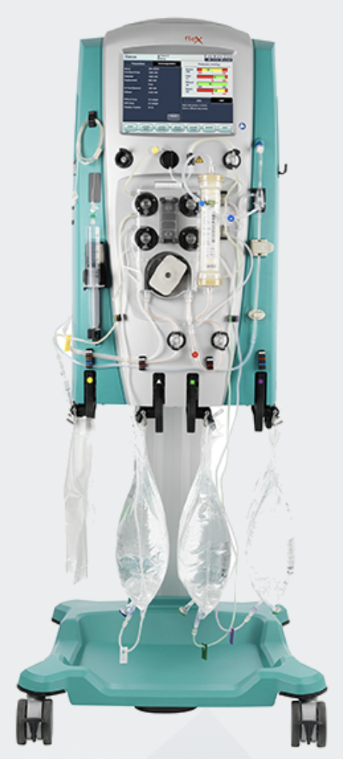
Definitions
RRT encompasses several treatment modalities, all supporting the impaired kidney. On ICU we are most commonly supporting patients with AKI and we use different modalities to those provided to patients with CKD.

Continuous vs intermittent
ICUs tend to use continuous RRT, as compared with intermittent haemodialyis (IHD) many CKD patients receive in the community.
IHD can involve blood flow rates of up to 500mL/min, and is a very efficient way of removing waste solutes such as urea. A single treatment can be completed in 3-4 hours.
These high flow rates can cause significant haemodynamic shifts, which in unwell patients can be poorly-tolerated and may even result in cardiovascular collapse. As a result, continuous modalities were developed, using blood flow rates from 100mL/min and working up to 250mL/min. This is less efficient and relies heavily on us managing to maintain continuous therapy and minimising interruptions - often easier said than done!
Fig. 1 - Prismaflex RRT system, adapted from Baxter Prismaflex product information, https://www.baxter.com/healthcare-professionals/critical-care/prismaflex-system-critical-care, accessed 25/1/22
Arterio-venous vs veno-venous
Early machines used the arterial blood pressure to drive blood out through an arterial cannula, round the system and back into a venous cannula. Arterial access cannulae needed to be big and were associated with complications, plus shocked patients often had insufficient blood pressure to drive the system effectively.

Modern machines use a single venous cannula with two lumens and a blood pump to drive the blood round.

Dialysis vs filtration
The majority of UK ICUs use filtration, rather than dialysis, with a small number using a combination, known as diafiltration.
Largely, dialysis is more efficient at removing solutes quickly and filtration is better for removal of fluid.

Abbreviations
CVVHF - continuous veno-venous haemofiltration
CVVHD - continuous veno-venous haemodialysis
CVVHDF - continuous veno-venous haemodiafiltration

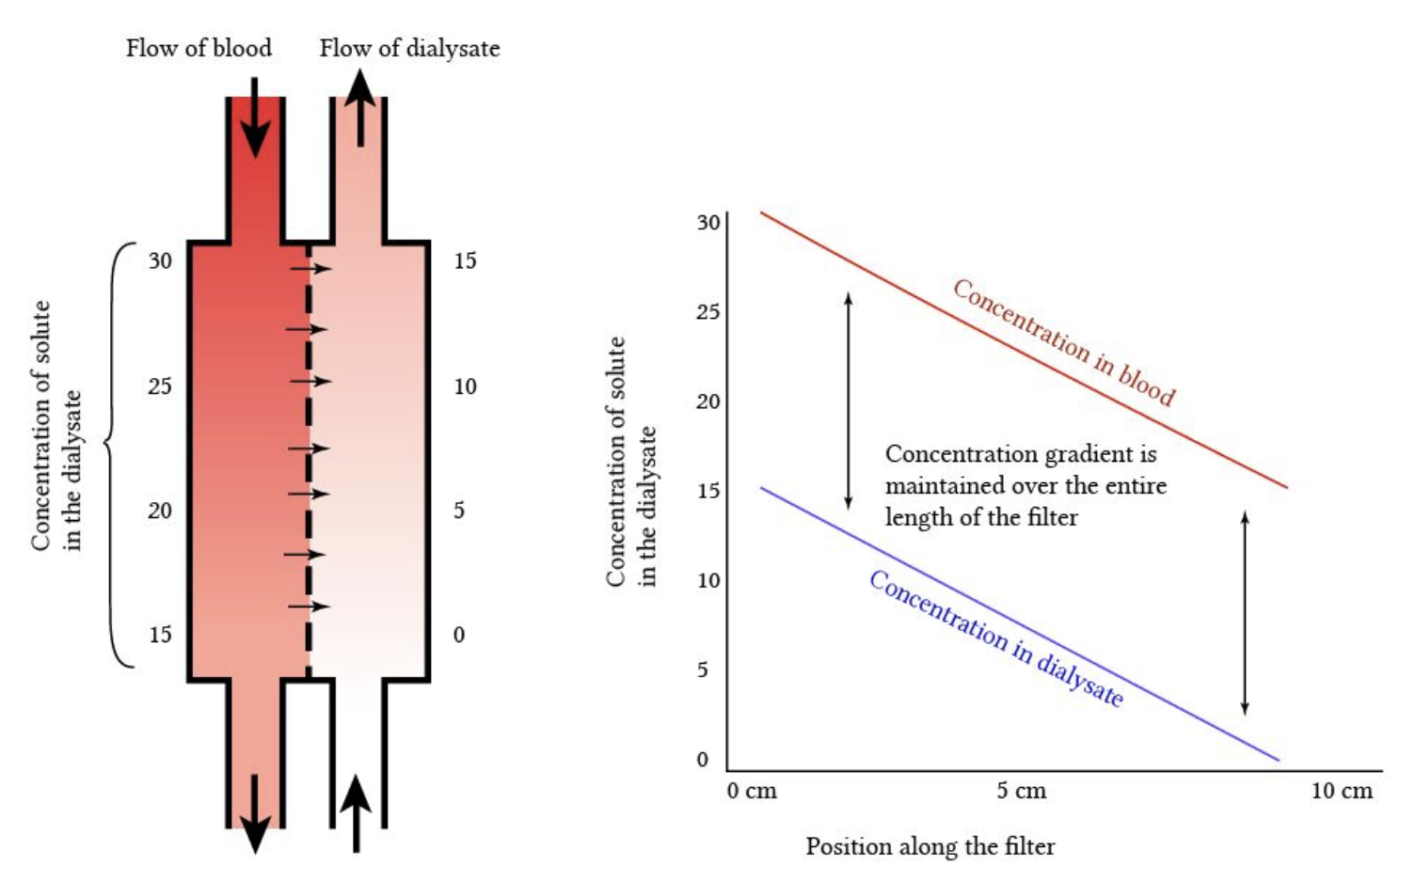
Fig. 2 - schematic of dialysis - diffusion of solute across semi-permeable membrane, with countercurrent dialysate flow maintaining constant diffusion gradient across whole length of filter.
Adapted from derangedphysiology.com, accessed 25/1/22

Equipment
You will need..!
- Vascular access device - large-bore, dual-lumen catheter in central vein (VasCath)
- Tubing - biocompatible to minimise immune activation, often heparin-bonded to minimise coagulation activation
- Pumps - one for blood +/- one for dialysate
- Filter - synthetic nowadays, densely packed hollow fibres with specific pore size
- Replacement fluid or dialysate
- Anticoagulant - see section below
- Various pressure gauges, air traps, leak detectors, etc…

Physical principles
Dialysis works on the physical principle of diffusion, with solutes moving across the semi-permeable membrane down a diffusion gradient. This gradient is maintained by a counter-current
mechanism, where blood and dialysate fluid (carefully balanced and buffered solution of electrolytes in purified water) are infused in opposite directions on either side of the membrane (see Fig. 2 and 3).

Filtration works on the physical principle of convection. The same semi-permeable membrane is used, with the patient’s blood passed over it under pressure. This causes “ultrafiltration” of the plasma component of the blood, which is forced through the filter membrane under pressure and carries solute particles with it by “solute drag” (see Fig. 3).
A very high proportion of the blood’s fluid component is ultrafiltered, meaning that the patient will require replacement fluid to prevent intravascular depletion. This can be introduced to the circuit either before or after the filter.

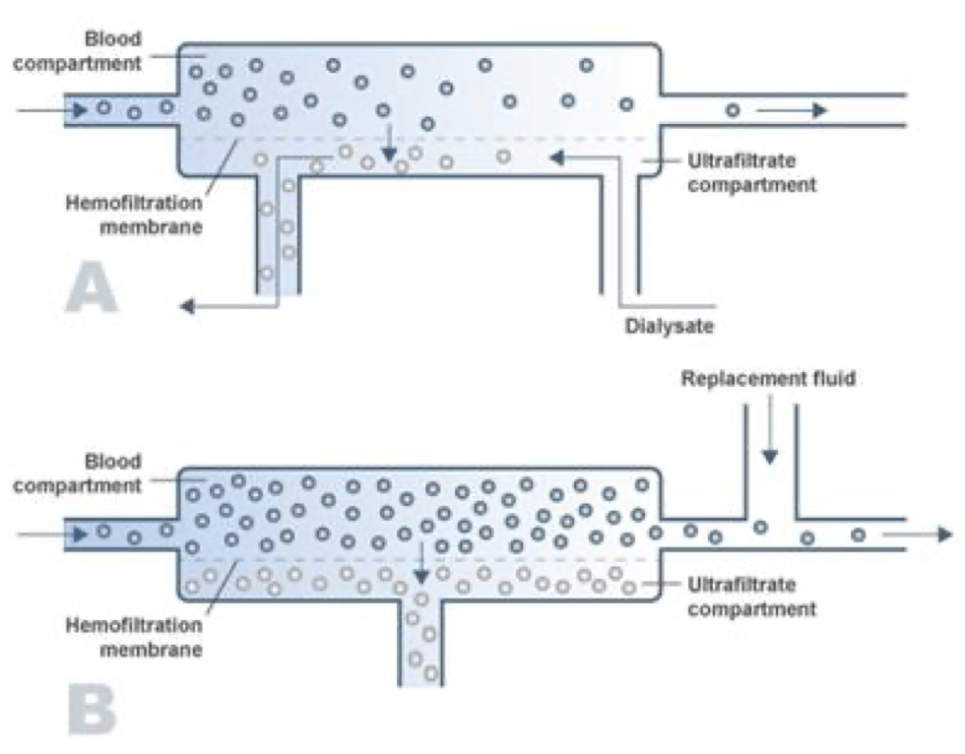
Fig. 3 - Schematic comparison of haemodialysis (A) and haemofiltration (B) across semi-permeable membrane. In A, countercurrent dialysate flow generates diffusion gradient. In B, blood is ultrafiltered through the membrane under pressure.
Adapted from https://www.health.qld.gov.au/__data/assets/pdf_file/0013/1020604/CCRM-Dialysis-Did-you-know_201227.pdf, accessed 25/1/22

Indications
Indications for urgent RRT can be recalled with the mnemonic AEIOU. RRT is indicated where there has been no response to initial medical therapy:

A | Acidosis
E | Electrolyte disturbance, particularly hyperkalaemia
I | Intoxication with dialysable toxins
O | Fluid overload
U | Uraemia with complications, e.g. pericarditis, encephalopathy

The dialysable toxins have their own mnemonic: I STUMBLE:

I | Isopropyl alcohol
S | Salicylates
T | Theophylline
U | Urea
M | Methanol
B | Barbiturates
L | Lithium
E | Ethylene glycol

Anticoagulation
In almost all cases, anticoagulation is needed to prevent activation of the coagulation cascade and clotting of the filter.
Previously, unfractionated heparin was commonly used, but this has been largely superseded by trisodium citrate. Citrate is a calcium chelator (calcium being an essential cofactor in the clotting cascade) and is added to the patient’s blood as it enters the filter circuit. Free calcium is then added back to the blood as it leaves the circuit and returns to the patient. In this way, only the circuit is anticoagulated, with very minimal effects on the patient themselves.
Over half the citrate-calcium complexes are removed by the filter. The rest are ideally “reversed” with the addition of more free calcium to the blood before its return.
Problems can arise with this balance however, leading to acid-base imbalance in the patient.
Citrate use is complex and potentially dangerous if not done properly, so is managed with a rigid protocol and close monitoring of blood gases and calcium.
Some very unwell patients, particularly those in decompensated liver failure can’t safely receive citrate, so might be managed with heparin or epoprostenol (Flolan) instead. Rarely, a patient’s haematology will be so abnormal that they don’t need anticoagulation. These decisions will be made by the consultants.

Dosing
Dosage of CVVHF is given as the ultrafiltration volume produced per hour. There is some evidence to suggest that dosages of 25-35mL/kg/hr are optimal. In a 70kg patient this works out at 1750-2450mL/hr. Some units will have a “standard” and an “enhanced” protocol

Complications
These can be split into complications of the access device, which are the same as those for any central line, and complications of the therapy itself:
- Haemodynamic instability - relating to the circuit removing around 250mL blood from an unwell patient. Often responds to a fluid bolus in the first instance, or a small increase in vasopressor.
- Bleeding - less common with citrate than previously with heparin, but can cause significant blood loss. Manage as for any major haemorrhage
- Blood loss in the circuit - if a filter clots without the blood being returned to the patient, the 250mL or so in the circuit will be lost. If repeated, anaemia will result. Can often be predicted by rising transmembrane pressure (TMP - pressure across the filter membrane)
- Filter clotting:
- Can be caused by low blood flows (may be related to poor vascular access not permitting optimal flow rates, pro-coagulant patient state, suboptimal anticoagulation. Might be prevented/delayed by increased blood flow rates or pre-filter dilution
- Thrombocytopaenia - slow drop can be caused by damage sustained in circuit but heparin-induced thrombocytopaenia should be borne in mind if heparin used
- Low PO4, Mg - often need replacing in patients on RRT as they are not usually contained in replacement fluid/dialysate, so are lost. Citrate also binds Mg to a lesser degree than Ca.
- Metabolic/acid-base abnormalities relating to replacement/dialysate fluid or citrate use - beyond the scope of this chapter! See your local RRT protocol for details.

Summary
In conclusion, there is an awful lot to RRT and you aren’t expected to know much about it and certainly not to manage it independently. Hopefully here we have managed to lay out the basic concepts, the components of the equipment and some of the aspects of the treatment that you might need to get involved in. If in doubt, ask a senior or the nurse in charge!

